Wednesday 3.3.21
English Task
Today, you are going to discover more about the weather in Florida, as this is the place you will be presenting your own weather forecast on. Please take a look at the websites and videos below:
https://www.bbc.co.uk/weather/3442585
https://www.holiday-weather.com/florida/forecast/
https://www.youtube.com/watch?v=FFIzAcVTGIM
You then need to read carefully through the following information (see video of me reading it) and highlight the important words and phrases.
In much of Florida, the climate is sub-tropical, with mild winters (but subject to short cold spells) and hot, sunny summers. Summer, from June to September, is also muggy and with frequent thunderstorms. In the far south, where Miami is located, the climate is tropical, since the average temperature in January reaches 20 °C. In summer and early autumn, Florida is prone to hurricanes.
In summer, temperatures are uniform from north to south, especially in the daytime, when they range between 31 °C and 33 °C while at night, they become warmer as you head south, in fact, they range from 21 °C in the far north to 27°C in the Keys. On the contrary, temperatures in winter are very different: in January, the daily average ranges from 11 °C in the north (where it is similar to that of many Mediterranean areas) to 20 °C in the far south. In summer, it's especially the high humidity that makes the heat uncomfortable, although periods of intense heat are also possible, with highs about 37/38 °C. Afternoon breezes and thunderstorms give a bit of relief, otherwise, you can swim in the sea or take refuge in air-conditioned buildings.

Reading Task
Please watch the video of me reading The Great Kapok Tree. Then answer the questions set out day by day on the separate document.
Maths
Starter
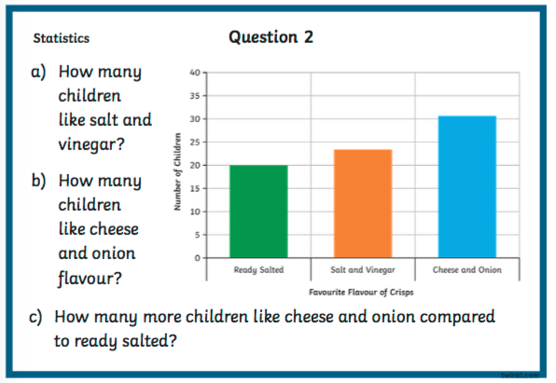

Main Task (see video)
We are going to put our data on the outside temperature into a horizontal bar graph (year 3) or a line graph (year 4). Please see the teaching video and then create your bar or line graph, either using the data below or your own data if you collected this yesterday.
Time | Temperature
9am | 5 °c
11am | 7 °c
1pm | 11 °c
3pm | 12 °c

Reading Comprehension
Please see separate document with a video link and questions.
Art/DT
We are going to create our Mount Quadring sculptures that we designed last week. Please see the below recipe for salt dough (or you can use play dough, or clay, whatever you have available). I would love to see some photos of the finished models!
https://www.bbcgoodfood.com/howto/guide/how-make-salt-dough-recipe

