Thursday 4.3.21
English Task
We are continuing to discover more about the weather in Florida. You need to find the definitions of the words below, you can use a dictionary or an online dictionary.
Climate
Subtropical
Tropical
Cyclone
Latitude
Conserve
Sleet

Then you need to highlight the important words and phrases from the passage below:
The climate of the north and central parts of the US state of Florida is humid subtropical. South Florida has a tropical climate. There is a rainy season from May until October; there are also a lot of thunderstorms during this time with a heavy rainfall. In late summer there are sometimes topical cyclones that contribute to the heavy rainfall.
In October the dry season sets in across much of Florida (starting early in the month in northern Florida and near the end of the month in deep southern Florida) and lasts until late April in most years. Fronts from mid-latitude storms north of Florida occasionally pass through northern and central parts of the state, which bring light and brief winter rainfall. Mid and late winter can become severely dry in Florida. In some years the dry season becomes quite severe and water restrictions are imposed to conserve water. While most areas of Florida do not experience any type of frost, north Florida can see fleeting snow or sleet a few times each decade.
Along the Gulf Stream the tropical ocean current provides warm sea surface temperatures, giving Florida beaches the warmest ocean surf waves on the United States mainland.

Reading Task
Please watch the video of me reading The Great Kapok Tree. Then answer the questions set out day by day on the separate document.
Maths
Starter
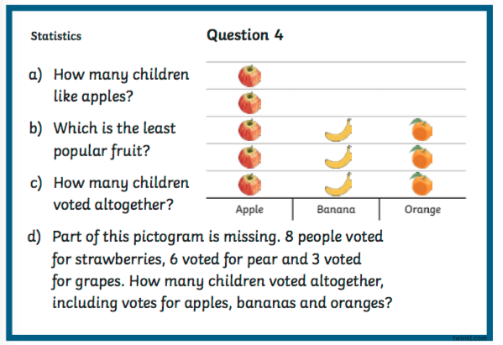

Main Task (see video)
You are going to create a pictogram based on the information in the table below about favourite fruits. Remember to look back at your work you’ve already done on pictograms.
Fruit | Number of children
Banana | 6
Apple | 8
Orange | 2
Strawberry | 12
Watermelon | 1
PE
Please see below links for PE videos:
https://www.youtube.com/watch?v=6v-a_dpwhro
https://www.youtube.com/watch?v=qGKGNzNbWjU
https://www.youtube.com/watch?v=U9Q6FKF12Qs
https://www.youtube.com/watch?v=hUBRoLRioiY
Spelling
Please ask your grown up to read out your spellings to you, and you can try your best to spell them correctly.

