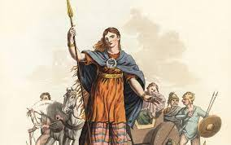
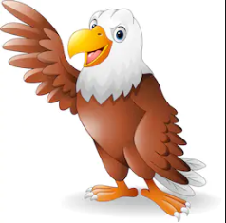

Maths
Place value
Addition & subtraction
Multiplication & Division
Shape
Money
Grammar
Word classes
Sentence structure
Paragraphs
Statements, commands, questions
Conjunctions
Apostrophes
Science
Light and Sound
Why we need light to see
Reflections and shadows
How sounds are made
How we hear
Pitches of sounds

English
Instructions
Diary entry
Recount
Setting description
Narrative
Newspaper article

Roman mosaic
Model of colosseum
Computing
E safety

Spelling – suffixes
-ful
-ly
-ed
-ing
-y

Music
Beats and rhythms
Recognising musical notes

Golden Eagles
Term 1
The Romans

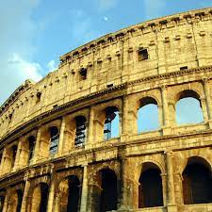
History
Roman life and beliefs
Julius Caesar invasion
Boudica
The Roman Empire

Geography
Locations of the Roman empire
Location of where Hinduism was founded

R.E
Hinduism
DT
Roman catapult
Roman bread
P.E
Football & Tri-golf
Times Tables
2s, 4s and 8s
Problem solving and word problems

