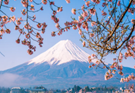
Japanese food – consists mainly of fish, rice and noodles
Sushi | Rice with vegetables or fish | 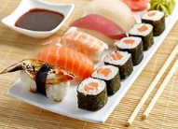
Ramen | Noodles in soup | 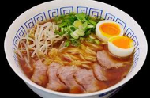
Miso soup | Bean paste with seaweed and tofu | 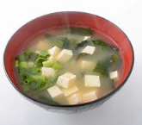

Japanese Art
Woodblock print – ukiyo-e This is a traditional printing style. Hokusai (1760-1849) was a famous woodblock artist and created thousands of prints. The Great Wave at Kanagawa is his most famous woodblock print.
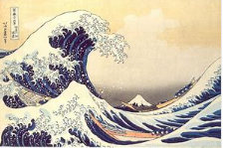
Origami – paper folding By folding one piece of paper, objects (often animals) can be made.
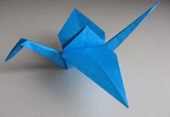

The Country 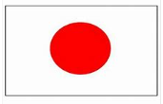
- Japan is known as the Land of the rising sun and their flag depicts this
- Japan is made up of 4 main islands: Hokkaido, Honshu, Kyushu and Shikoku
- The capital city is Tokyo
- The highest mountain is Mount Fuji (a volcano)
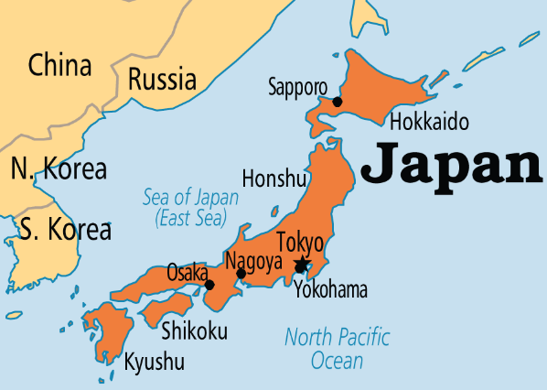
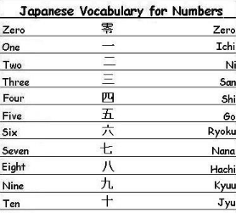

Japanese greetings
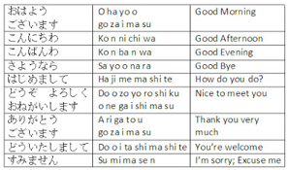

JAPAN
Japanese poetry – Haiku
Haiku is a traditional style of Japanese poetry consisting of 3 lines. In the first verse there are 5 syllables, the second has seven syllables and the third has five. Haikus are usually about nature. Basho was the most famous Japanese Haiku poet.
Eg. Flowers are blooming
Rainbow colours paint the ground
Red, yellow and blue

Japanese Music
Taiko drumming – traditional Japanese drumming
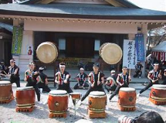
Karaoke – means ‘empty orchestra’.


