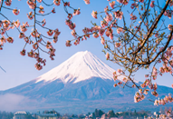
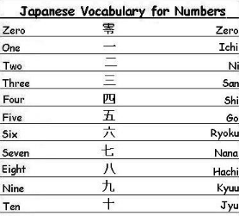

Japanese poetry

The Country 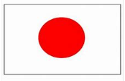
- Japan is known as the Land of the rising sun and their flag depicts this
- Japan is made up of 4 main islands: Hokkaido, Honshu, Kyushu and Shikoku
- The capital city is Tokyo
- The highest mountain is Mount Fuji (a volcano)
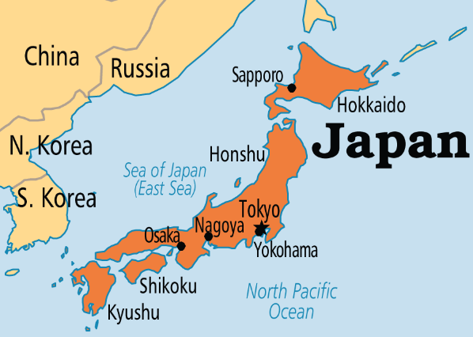
Japanese food
Sushi | Rice with vegetable or fish
Ramen | Noodles in soup
Bento | Lunch box
Miso soup | Bean paste with seaweed and tofu
Soba | Noodles
Tempura | Vegetables or fish in batter
Yakitori | Chicken skewers

JAPAN
Japanese greetings

Japanese Music
Taiko drumming

Karaoke

J-Pop
Japanese Art
Woodblock print – ukio e

Origami – paper folding

