Welcome to Barn Owls!
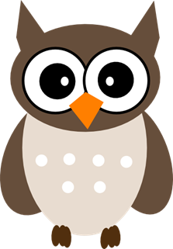
Information for Parents, Carers and Pupils
2020/21

Meet the Barn Owls team
Mrs Wood is the class teacher and Mrs Sharman and Mrs Jones are the teaching assistants.
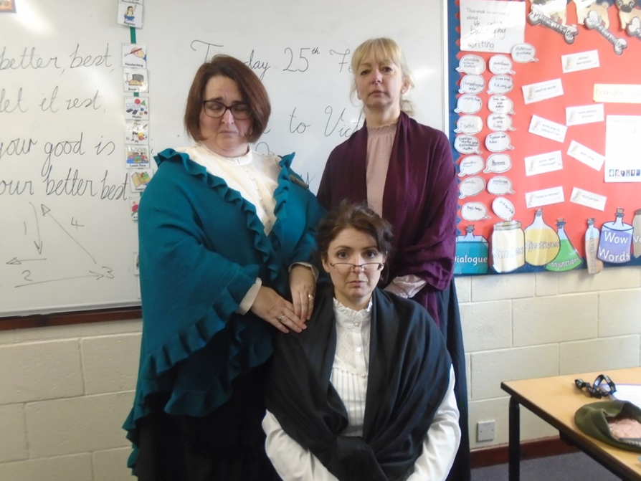
Expectations
At the start of the term we discuss rights and responsibilities with the class and they write their own class charter.
We have high expectations in Barn Owls.
- We expect Barn Owls to be kind and respectful.
- We have high expectations of behaviour.
- We expect the children to try their best.
- We focus on personal improvement from whatever starting point a child has.
- We expect children to present their work neatly.
- We work hard and play hard in Barn Owls!

Curriculum
Writing – eg. newspaper articles, diary writing, perspective writing, biographies, information writing, narrative. We use experiences, books and video clips as stimuli and wherever possible we link this to the topics we are learning about.
Maths – arithmetic and reasoning. They must have instant recall of timestables (this is a government expectation for the end of Year 4). We have a timestable test each week.
Grammar, punctuation and spelling – we have a grammar and punctuation focused lesson each week and a spelling test each week
Sports – including opportunities to represent the school at a range of sports (dependent on restrictions)
Other topics: linked together in a ‘creative curriculum’
Topics
Our main topics this year will be Japan, The Victorians and Ancient Greece
Reading Challenge
Barn Owls children are expected to read every day and this needs to be recorded in the Reading Record book. Year 5 are expected to read 10 pages per day. Year 6 are expected to read 15 - 20 pages per day
In class, we have a reading challenge where children can earn points for the books that they read. When children reach certain amounts of points, they win prizes.
Homework Expectations
Every week, the children will be given the following as homework:
- Timestables (in preparation for the timestables challenge every Friday)
- Spellings (in preparation for the spelling test every Friday)
- Grammar and punctuation (based upon that week’s learning)
- Maths (based upon that week’s learning)
Times tables
Times tables will be tested every Friday. For the first few weeks of term, we will be concentrating on consolidation of the timestables and children will be expected to know each timetable thoroughly before they can move on to the mixed timestables. For the first few weeks they will be tested on multiplication and division facts (e.g. 5 x 2 =?, 20 ÷ 2 =?). For each timetable they will be expected to get 21 out of 24 questions correct in under 2 minutes.
Once all timetables have been completed, they will move on to the mixed timetable challenge. There are 96 questions to complete. The aim is for the children to beat their previous score each week. One way that has proved particularly useful for practising times tables is the use of online apps and games – including Timestables Rock Stars.
http://www.mad4maths.com/multiplication_table_math_games/
http://www.math-salamanders.com/online-multiplication.html
http://www.learnyourtables.co.uk/en/index2.htm
https://ttrockstars.com/
A range of times tables apps can be downloaded free of charge from the apple and google stores.
Spellings
The children will be given spellings based upon the year 5/6 English curriculum every Friday which are based upon a particular spelling rule. Homework will be given to support this. These spellings will then be revisited on Monday and given as handwriting practice on a Wednesday. The spellings will be tested on the following Friday. Homework is handed in on Wednesday so on Wednesday the children are given a spelling list so they can carry on practising at home.
Grammar/Punctuation and Maths
The children will be given a maths task and a grammar/ punctuation task every Friday to complete for homework. This will consolidate the learning from that week.
Homework completion
Homework is be expected to be handed in every Wednesday.
Website
Please keep checking the Barn Owls webpage to see photos of what we have been doing at school and examples of work. https://www.quadringprimary.co.uk/barn-owls-5/
SATs
Year 6 children take KS2 SATs (standard assessment tests) on grammar punctuation and spelling, reading and maths (arithmetic and reasoning). These tests will take place Monday 9th May – Thursday 12th May 2022.
11+
The 11+ in Lincolnshire is administered by the grammar schools.
https://grammarschools.lincs.sch.uk/home/

Working together
We are looking forward to working with you and teaching and supporting your child(ren).
Please let us know if you have any questions or comments or things that you feel we should know.
We will always make time to see you if you want to talk to us. Please e mail barnowls@quadringcowleybrowns.lincs.sch.uk or make an appointment at the school office and we will get back to you as soon as possible.
Thank you for your support
Parents and carers are the most influential people in their children’s learning. Your support makes a huge difference – thank you!
The Barn Owls Team: Mrs Wood, Mrs Sharman and Mrs Jones



