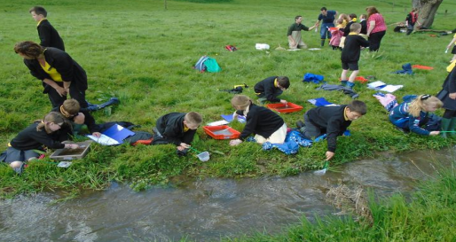
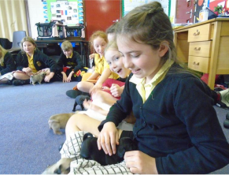
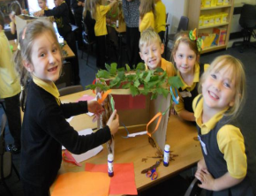
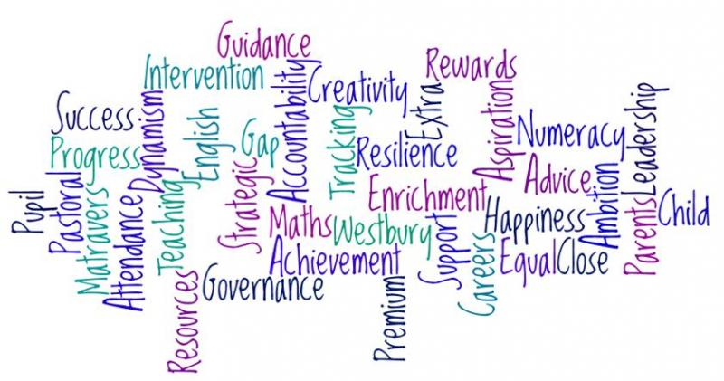







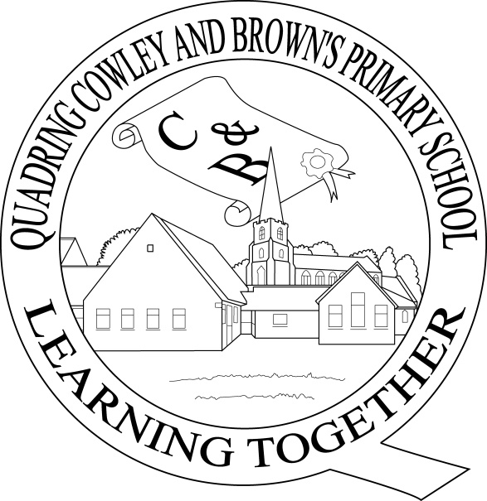
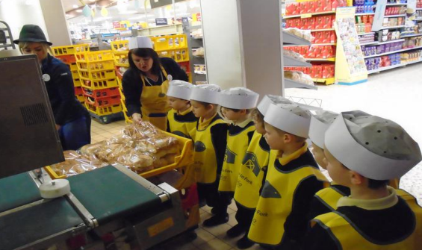
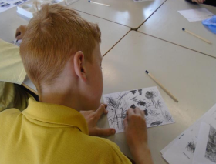
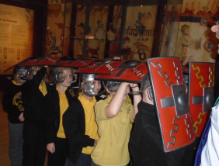
What is the Pupil Premium?

Dear Parents/Carers/Guardians,

Did you know that your child’s school could be missing out on more than £1,200 of funding per year for 6 YEARS to help your child to succeed? Schools in Lincolnshire are amongst the lowest funded in England, so think what a difference this funding might make to your child’s future: better resources, more staff to help in class, financial support for you towards trips, clubs and uniform, specialist training for staff, more catchup groups, more support with key skills and mentoring.

We think there may be many families who could be eligible, but have not applied for a range of reasons.

The purpose of the Pupil Premium is to help schools to provide targeted support for these students. We decide how to use the funding and our efforts are focused on supporting the learning of targeted students. The Government does not prescribe how we use the funding.

For details and reports on how we, at Quadring, use Pupil Premium funding, visit http://www.quadringprimary.co.uk/pupil-premium/

As always, we are more than happy to chat to families, in confidence, who meet the criteria. Please feel free to speak directly to Mr. Kelwick or make an appointment via the school office.
Thank you.

Mr. J. Kelwick, Head teacher
Partners
www.quadringprimary.co.uk
Tel: 01775 820302
Why is the Government providing the Pupil Premium?
Poverty or low income is the single most important factor in predicting a child’s future life chances, with many pupils having low attainment by the time they leave school at age 16. The Government believes that the Pupil Premium is the best way to address these underlying inequalities between children eligible for free school meals (FSM) and their peers by ensuring that funding to tackle disadvantage reaches the pupils who need it most.

Who receives the Pupil Premium?
Pupil Premium is allocated to pupils in school year groups from Reception to Year 11 from low income families who are registered for FSM, or who have been registered for FSM at any point in the last six years (known as ‘Ever 6’), together with children that have been in care continuously for 6 months or more.

What is the Service Premium?
The Service Premium grant is for pupils who have a parent serving in the armed services. Unlike the Pupil Premium, this grant is not solely for raising attainment but for providing additional (mainly pastoral) support.

Quadring Cowley and Brown’s Primary School

Pupil Premium Guide

Useful Websites

DfE guidance on funding and accountability for schools
https://www.gov.uk/guidance/pupil-premium-information-for-schools-and-alternative-provision-settings
Our own Pupil Premium Section on the schools website
http://www.quadringprimary.co.uk/pupil-premium/
General government information
http://www.education.gov.uk/schools/pupilsupport/premium
Lincolnshire County Council information
https://www.lincolnshire.gov.uk/parents/schools/virtual-school/additional-funding-to-schools/126842.article

Who receives the Service Premium?
Pupils with a parent currently serving in the armed services and supporting their family, pupils who have a parent who died in action and those whose parents have left the service since April 2011 for other reasons, including injury. To be eligible, the parent must be supporting their family, so where they are separated or divorced a pupil will not be eligible.

How do parents register their child’s entitlement for Pupil Premium?

Parents must apply for free school meals via the County Council or their child’s school, this is a quick and simple process. Telephone 0845 155 1019 with your National Insurance Number, date of birth, name and child’s details and an eligibility check can be carried out using the Department for Education’s Eligibility Checking System, this will confirm if details have been matched or not. It will not tell us what benefits you are in receipt of, dates when a benefit was awarded or say how much you receive. Confirmation will be sent to you and the school within 5-10 working days

Pupils do not have to take up their entitlement to a free meal but Local Authorities and schools recommend that they do.

The government is made aware of each pupil claiming FSMs each term via the school census so they have up-to-date information on those eligible
Self-Audit
We think there may be some families who are not sure if they qualify for the Pupil Premium Grant for their child or children. Complete this self-audit to see if you are.
Money is paid to schools to support children:-
(please √ any that apply to your child)

- Who have parents/carers who work in the armed forces
- Who are in the care of the Local Authority foster care/residential care
- Who have been adopted from care on or after 29th December 2005 or who have left care under a special guardianship order or who have left care under a residence order.
- Who have parents/carers who receive Income support or Income-based Jobseeker’s Allowance or
- Who have parents who receive Employment and Support Allowance (Income Related)
- Have parents who receive support under Park VI of the Immigration and Asylum Act 1999
- Have parents who receive Child Tax Credit with Working Tax Credit and where the household income is as assessed by Her Majesty’s Revenue and Customs as not exceeding £16,190 (subject to annual review)
- Have parents who receive the guaranteed element of state pension credit
- Who have receive free schools meals at any time in the last 6 years.

Self-Audit (continued)
- Parents who are made redundant or start working less than 16 hours per week, may find their children are entitled to free meals for a limited period.
- As of September 2014 all EYFS and Key Stage 1 children will be entitled to a Universal Free School Meal, however this is not linked to additional funding for each child.
- If you believe you would meet the above criteria please follow the link below as this will provide the extra funding of £1,320 to support your child in school.

If you have ticked any of the boxes, then please come and speak to the Head teacher, Mr. Kelwick, or Senior Administrator, Mrs. Bemrose, in confidence.

Early Years Pupil Premium Grant
All children aged three and four (not two year olds), who meet the eligibility criteria will benefit from the funding. This funding is paid directly to us on an hourly rate basis, linked to claimed hours for entitled children. The annual value for a 15 hour place over a full year is just over £300 and since we are registered to offer early years places we can receive the EYPP. In order to be able to claim this funding we require parents to sign the funding agreement which asks for details of parent’s date of birth and National Insurance number.
Which three-and four-year-olds will be eligible for the EYPP?
The Department for Education (DfE) introduced an Early Years Pupil Premium
(EYPP) for eligible 3 and 4 year old children in April 2015. This is an exciting initiative for children whose parents/carers meet one of the following criteria (similar to the self-audit):
- Economic – The family are in receipt of one of the following:
- Income Support
- Income-based Jobseeker’s Allowance
- Income-related Employment and Support Allowance
- Support under part V1 of the Immigration and Asylum Act 1999
- The guaranteed element of State Pension Credit
- Child tax Credit and have an annual gross income of no more than £16,190
- Working Tax Credit Run-on (this is paid for 4 weeks after they stop qualifying for Working tax Credit)
- Children who have left the care of a local authority as a result of an adoption order in England or Wales
- Children who have left the care of a local authority as a result of a special guardianship order in England or Wales
- Children who have left the care of a local authority as a result of a child arrangements order in England or Wales
- Children who have been looked after by a local authority for 1 day or more in England or Wales.

How effective is Feedback?
According to the Education Endowment Fund (EEF) Toolkit, feedback studies tend to show very high effects on learning. However, it also has a very high range of effects and some studies show that feedback can have negative effects and make things worse. It is therefore important to understand the potential benefits and the possible limitations of the approach. In general, research-based approaches that explicitly aim to provide feedback to learners, such as Bloom’s ‘mastery learning’, tend to have a positive impact. Feedback has effects across all age groups. Research in schools has focused particularly on its impact on English, mathematics and, to a lesser extent, science.

Research evidence about feedback was part of the rationale for Assessment for Learning (AfL). One evaluation of AfL indicated an impact of half of a GCSE grade per student per subject is achievable, which would be in line with the wider evidence about feedback.

Sampling and Scrutiny
The Senior Leadership Team and Subject
Leaders will conduct book sampling at least once every term to assess the impact of marking and feedback on learning. Additionally, pupils will be consulted on how effective they find feedback from their teachers which will then able us to measure this individual progress. Work in Years 2 and 6 is regularly monitored by fellow professionals from other schools and we constantly strive to study best practise in this field to enhance the marking and feedback process.

