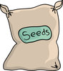
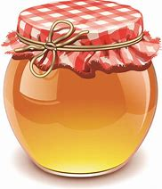
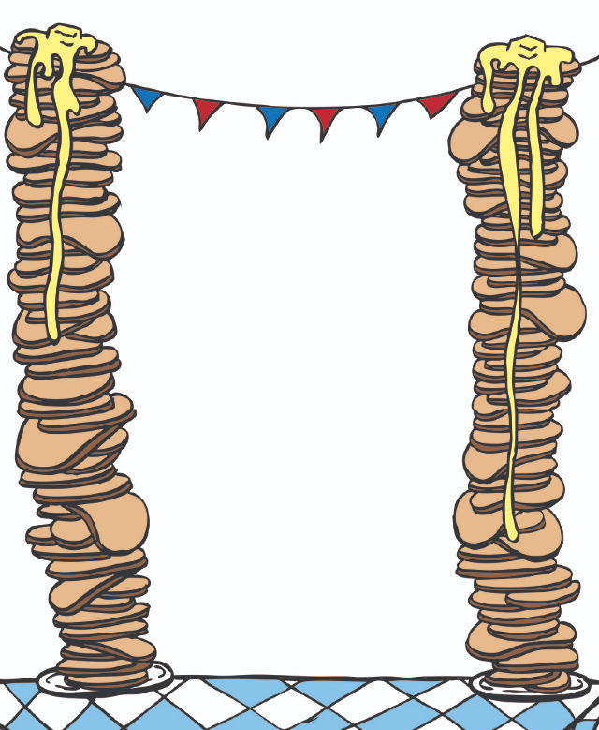
Ancient Greek pancakes
You will need:
  - 1 cup flour
  - 1 cup water
  - 2 tbsp honey
  - 1 tbsp sesame seeds
  - Olive oil
Equipment:
  - Pan
  - Spatula
  - Bowl
  - Wooden spoon
Method:
1) Mix flour, water and one tbsp of honey in your bowl.
2) Next, heat some olive oil in your pan.
3) After that, add ¼ of the batter in the pan.
4) When mixture thickens turn your pancakes over 2-3 times with your spatula.
5) Make sure your pancakes are golden both sides.
6) Make three more pancakes with batter.
7) Add 1 tbsp of sesame seeds and 1 tbsp of honey on the top.
8) Finally, sit back and enjoy your Greek Pancakes.

