GREEK STYLE PANCAKES

This recipe comes from ancient Greece and is still used in Greece today.

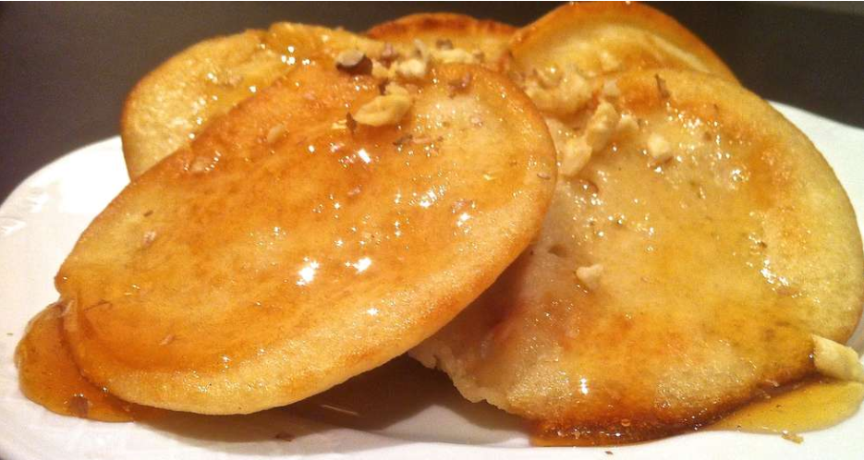

You will need :
- 1 cup of flour
- Pinch of salt
- 1 cup water
- 2 table spoons of honey
- Olive oil for frying
- Honey for drizzling
- Walnuts for sprinkling

Method :

- Firstly, wash your hands
- Secondly accurately measure your ingredients
- Add flour to a mixing bowl
- Then stir in the water and honey keep stirring until a smooth batter forms
- Pour a few table spoons of olive oil to a frying pan and warm on a medium heat for a minute or two
- Add one quarter cup of batter for each pancake
- Cook each pancake on 1 side for 3 minutes or until set
- Flip the pancake for a minute or two until finally set
- Finally remove the pancake from the pan and repeat this until all batter is used.
- Serve with drizzled honey and sprinkle walnuts.

Enjoy!

