Ancient Greek Inventions

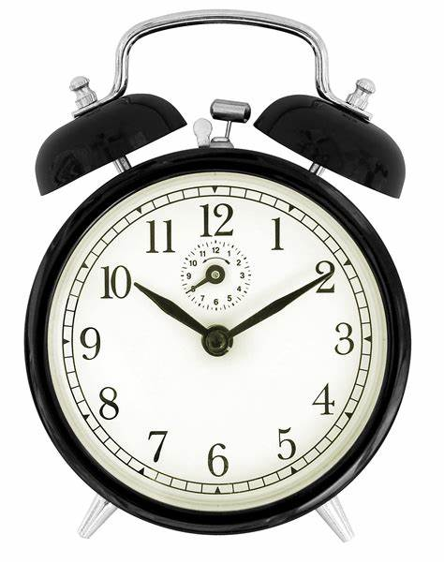
Have you ever wondered how a lot of the things that we use and take for granted were made? Thank the Ancient Greeks for inventing them! Here are just four of the many everyday items that they invented.

Alarm Clocks

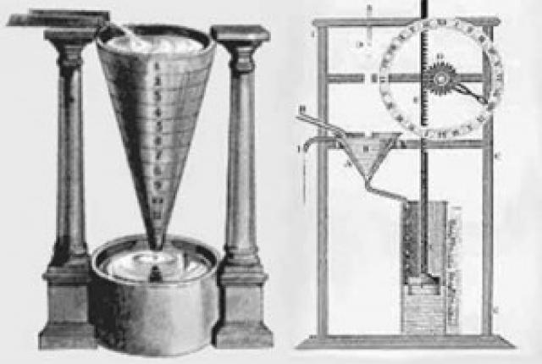
These great appliances can wake you up at whatever time you set them. Back in the Ancient Greek times, they used to be pieces of machinery that were used to time the alarm; it would then make a noise.

They often had devices called water
clocks which would drip water into a pot (its way of measuring time). When a specific level was reached over a certain amount of time, a lever triggered the alarm sound.

A man by the name of Plato, who lived from 428 to 348 BC and was a philosopher, thought to have owned a water clock at night – possibly used to tell him in the morning to go and teach.

Ancient Greek engineer and inventor Ctesibius improved his by putting in a dial, a pointer to signal the time and alarm systems with fine detail.

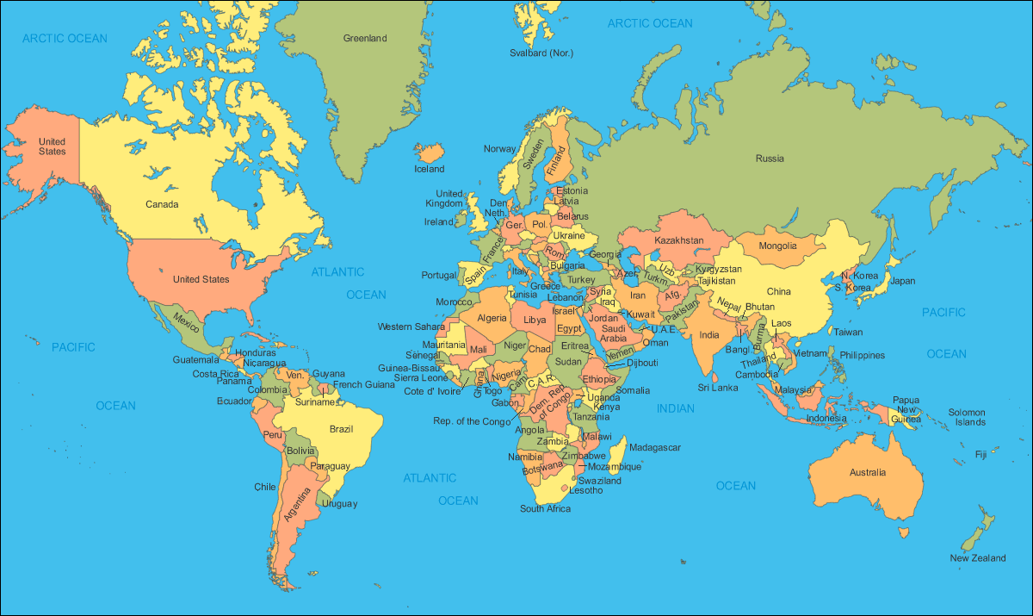
Cartography

Cartography means making maps. Since ancient times, it has been an important part of travel and navigation.

The earliest cartographers that are known are the Babylonians, somewhere around 900 BC, who drew simple maps that Ancient Greeks then improved.
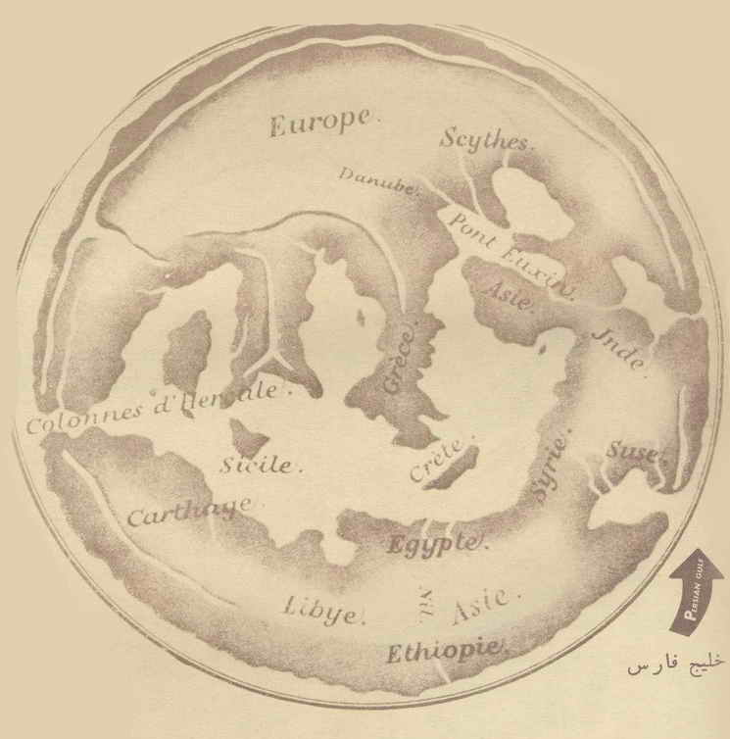
The first map of the world was made by Anaximander who was one of the first ever map makers. He made his map on a flat, smooth rock called a tablet; definitely not like a tablet today! He made his map of the world according to his beliefs with Greece in the middle. He was born between 611-610 BC and made some important contributions to the scientific areas of astronomy and geography. His maps showed places where the Ancient Greeks knew other people lived.
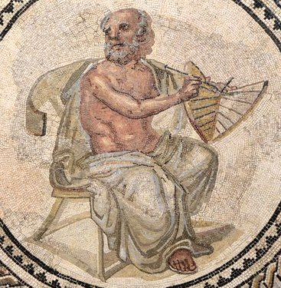
Of that time, Anaximander’s map of the world was an excellent achievement.

Olympics

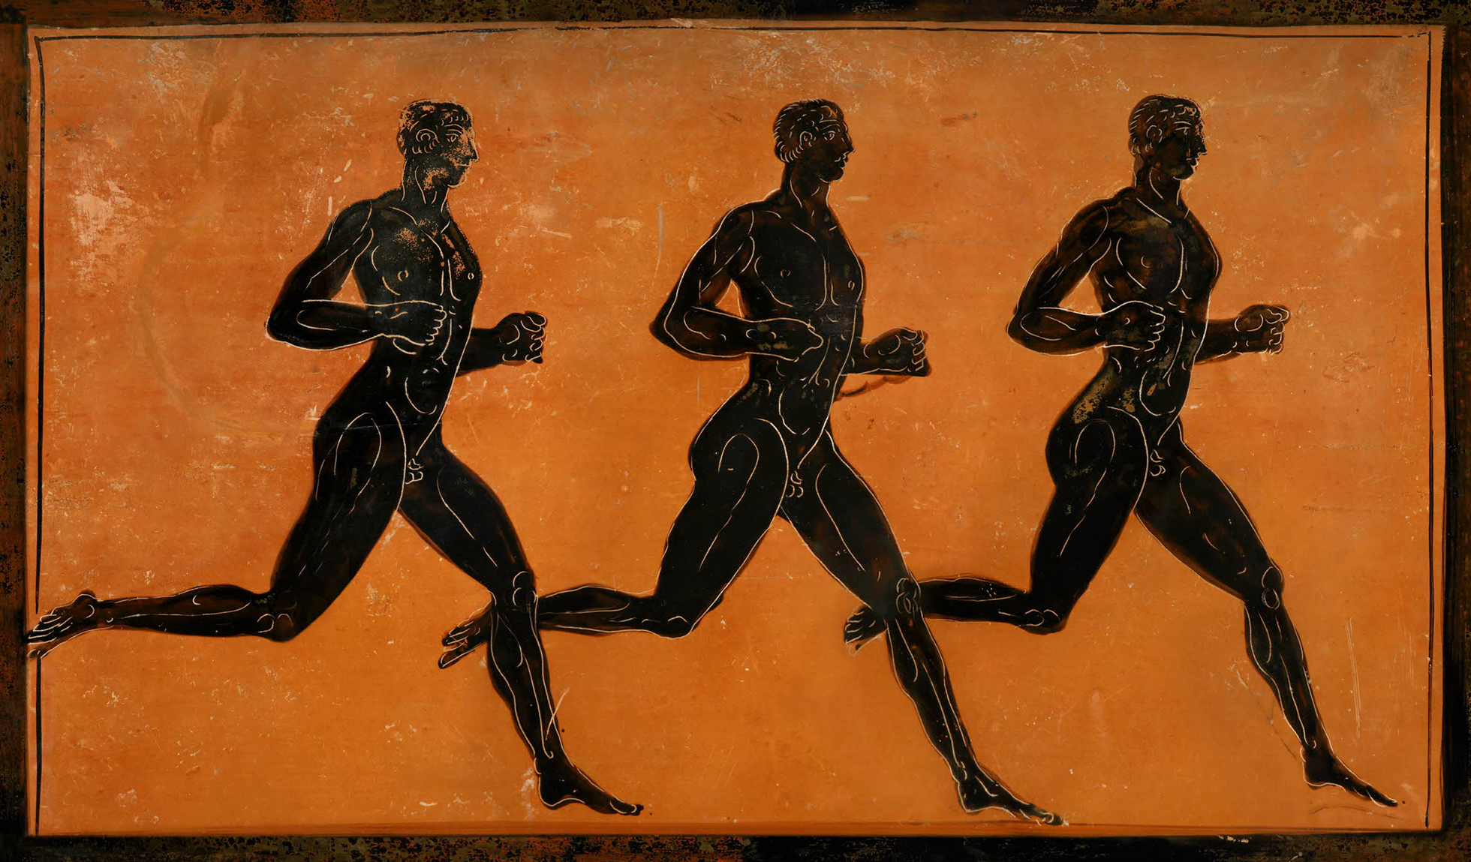
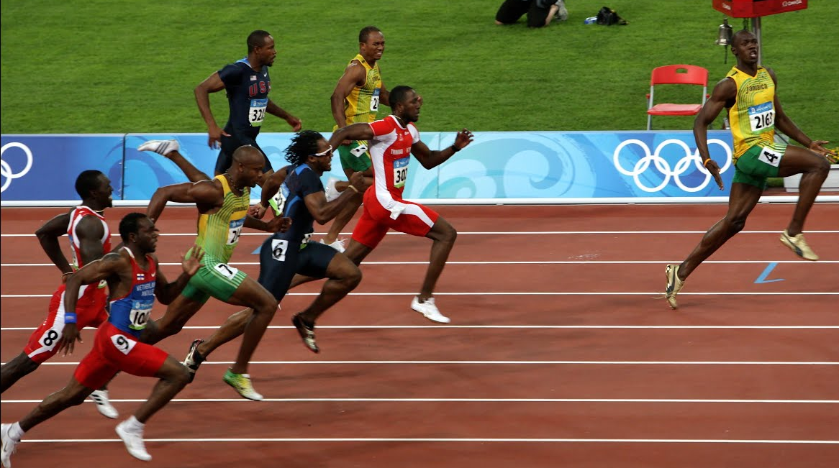
Pierre de Coubertin (founder of the modern Olympics) was inspired by the ancient Olympics in 776 BC.

Dedicated to the Olympian gods, the different events took place in different places.
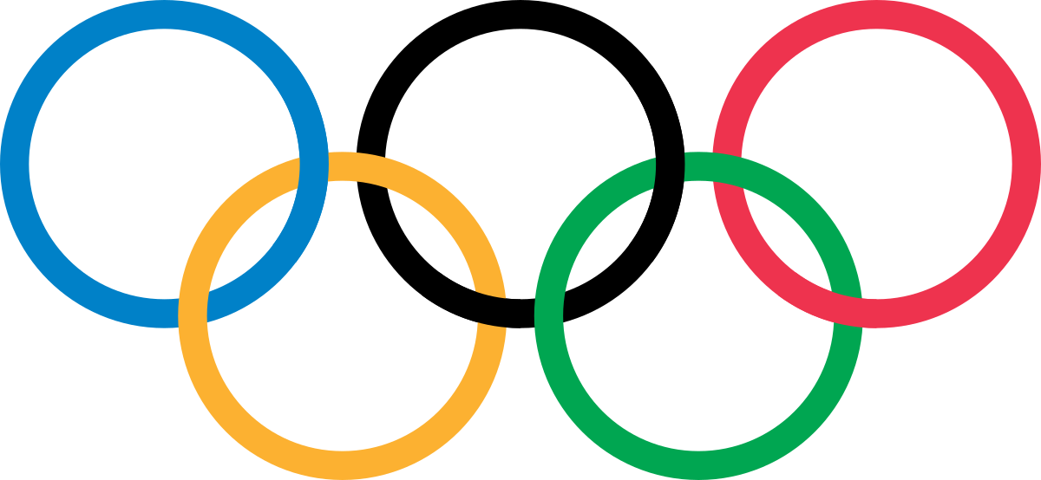
The Isthmos games were held every two years at the Isthmus of Corinth.
The Pythian games were held every four years near Delphi.
Also every four years, the most famous games in Olympia happened, which is south-west of Greece.

All of the locals came to watch and the winners
got olive leaf wreaths or crowns as their prize.

Practice of medicine
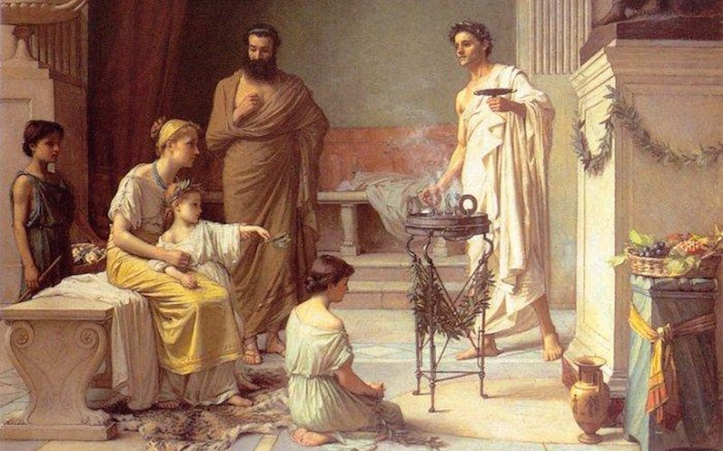



The Ancient world were not good at curing diseases.
Back then, they were thought to be God’s way of punishing humans.
All means of curing pain and diseases were surrounded by superstition.

But when Hippocrates of Cos collected data and conducted experiments to show that disease was natural, that signs and symptoms were made possible by the natural reactions of the body to the process of disease, that all changed.

He was an ancient Greek doctor of medicine born in the year 460 BC and was considered as one of the most important people in medicine history.
He is referred to as the father of western medicine because of his lasting contributions to the field as the founder of the Hippocratic School of Medicine.

The Hippocratic Oath is his most famous contribution which doctors had to promise to. This oath (a serious promise) included trying best to save patients and not harming or killing them.
The modern world still uses lots of ideas from the oath such as the doctor not discussing a patient’s illnesses with anyone else apart from the patient.


The Ancient Greeks made lots and lots and lots more inventions such as the vending machine, the odometer (used to measure the distance travelled by a vehicle), the water mill and the yo-yo just to name a few.

I hope you found this report useful!


