What did the Greeks Invent?

Lots of the interesting things the UK has now, were actually invented by the Greeks. If the Greeks hadn’t invented what they did, probably no one would have. Here we will take a look at some of their best inventions.

CHEESECAKE

Cheesecake was invented thousands of years ago by the Greeks. An Ancient Greek physician wrote a book about the art of cheesecake and the oldest recipe was made by Athenaeus in 230 A.D.
It was given to the athletes in the Olympic Games as a source of
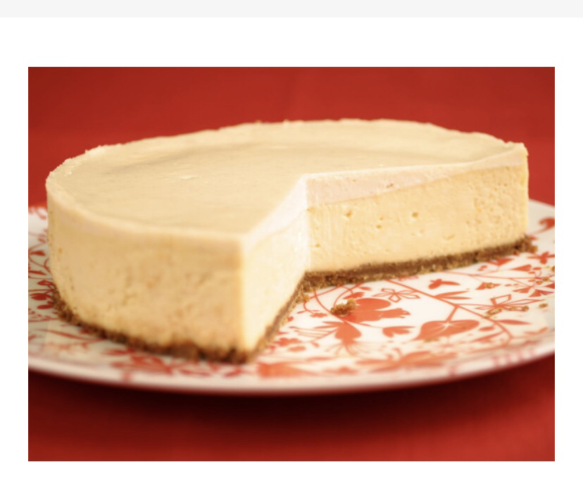
energy.

OLYMPIC GAMES

The first Olympic Games were in Olympia and began over 2700 years ago in 776BC. To begin with the only race was the 200 metre foot race. They went on to add more events. Every four years, around 50,000 people came from all over the Greek world to watch and take part.

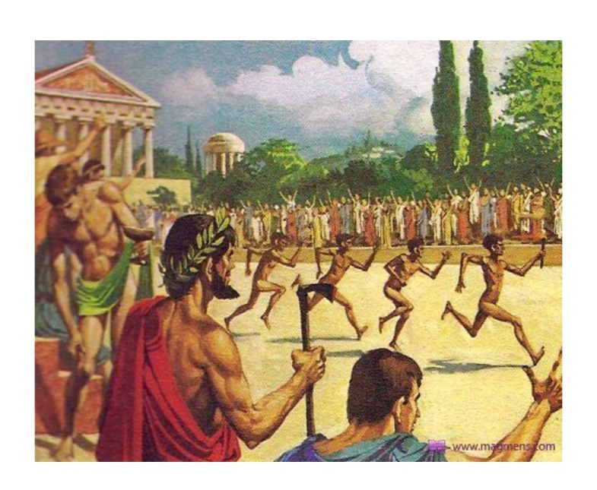
There were no bronze, silver or gold medals instead winners were given a wreath of leaves or a crown as a prize.
CATAPULT

The catapult was invented around 400BC in the Greek town Syracus. The name catapult was derived from the Greek word ‘Katapultos’. It was used for throwing heavy objects or arrows over a large distance. Later on wheels were added on it by the Romans in order to make it more manoeuvrable.
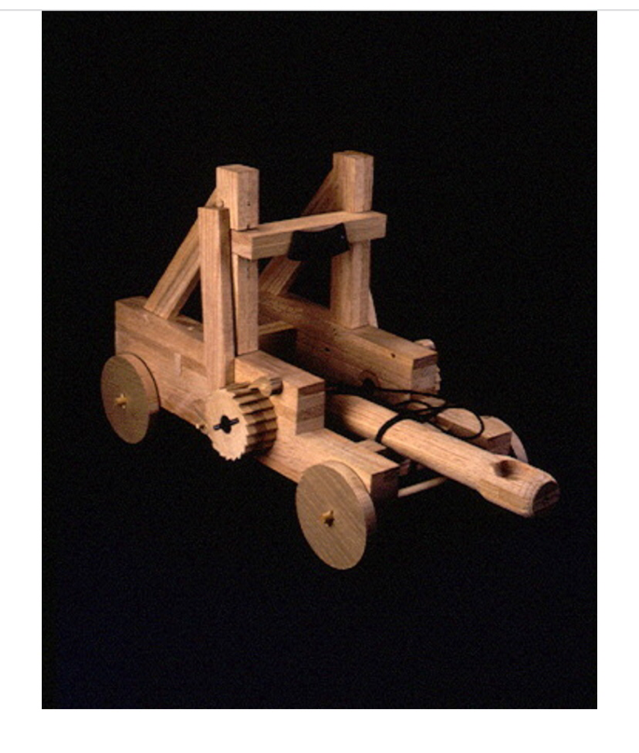

CRANES

In Greece, the crane was invented to make buildings and temples. It was used to carry heavy items by a rope attached to a wooden structure. It was powered by donkeys or by other animals who would have been able to carry the weight. They were invented in the late 6th century BC.
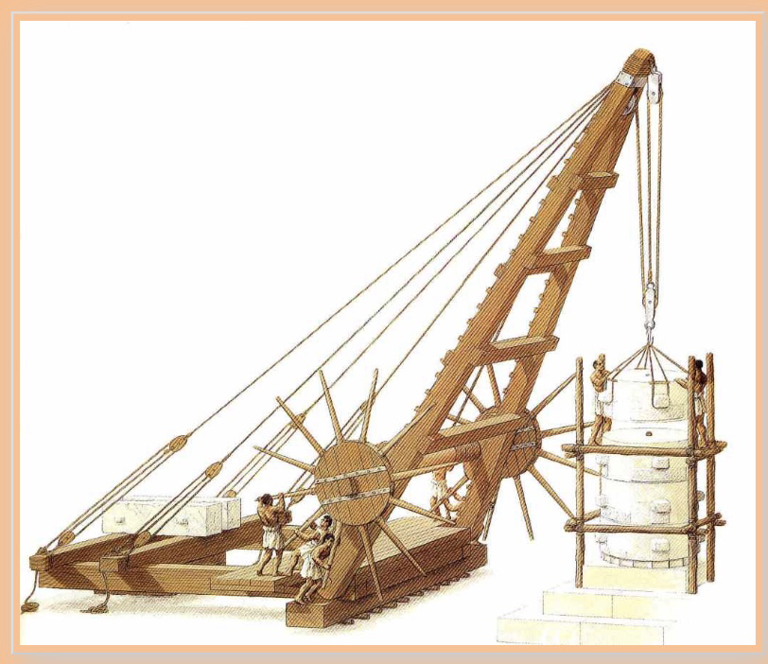

The Greeks invented many more things like the water mill, the alarm clock, the use of maps, the concept of democracy, the list goes on. So we can clearly see the Ancient Greeks did it first and did it better! Their inventions have gifted the world and most are still being used today in our daily lives.

By Billy-George Burwell

