Greek Inventions

Money
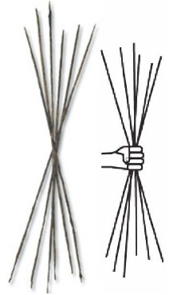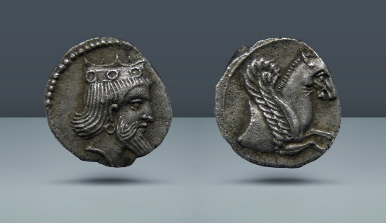
The Ancient Greeks have been using some form of money in exchange for goods and services since 1100 BC. They called their money drachma, but it wasn’t shaped like coins – it had the form of several long rods. It gave a way for people to value their goods and services in a more standard way. Once the drachma was invented, it changed the nature of the economics in Greece. Originally, the drachma coin was measured as 1/6 of a standard drachma rod and offered an easy way to break the drachma up into smaller units. The name drachma derives from the Greek verb meaning ‘to grasp’. It’s original value was the same to a handful of arrows.

Medicine
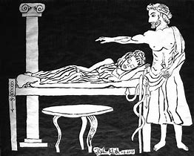
The Greeks were one of the first civilisations to study medicine as a scientific way to cure illnesses and diseases. They had doctors who studied sick people and then came up with some treatments. The most famous Greek doctor was Hippocrates. Hippocrates taught that diseases had natural causes and they could sometimes be cured by natural means. The Hippocratic Oath to uphold medical ethics is still taken by many medical students today.

Maps
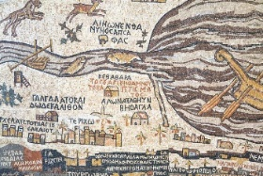
Map are one of the most ancient Greek inventions still used today. Research has shown that maps in the western literature were first produced in 6200 B.C. Anaximander (610-546 BC) was the first Greek Scholar to invent a map. The concept of longitude and latitude was introduced by a Greek geographer called Dikaiarch (350-290 BC).

Alarm Clocks
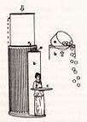
The alarm clock was created in 200 BC by the Ancient Greek inventor Ctesibius (285 to 222 BC). He fitted his water clock (clepsydras) with a dial and pointer to show the time. He also added an alarm system which could be made to drop pebbles on a gong at a pre-set time.

Olympic Games
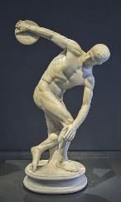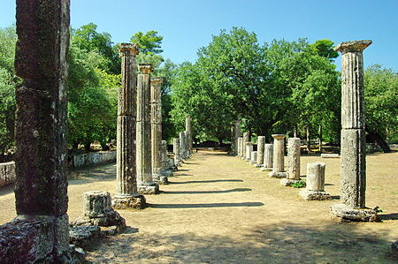
The first record of the Olympics being played was on the plains of Olympia in ancient Greece in 776 B.C. These games were originally a festival in celebration of Zeus and featured events such as wrestling and Javelin. These games lasted for one day, then in 472 B.C. new games were added and the event was extended to five days. The pictures show The Palaestra of Olympia where wrestlers trained. The statue is of ‘Discobolus’ an ancient Olympic discus thrower.

Olivia Winter

