Arthur the Croclegrog
My Miptor by Olivia Winter

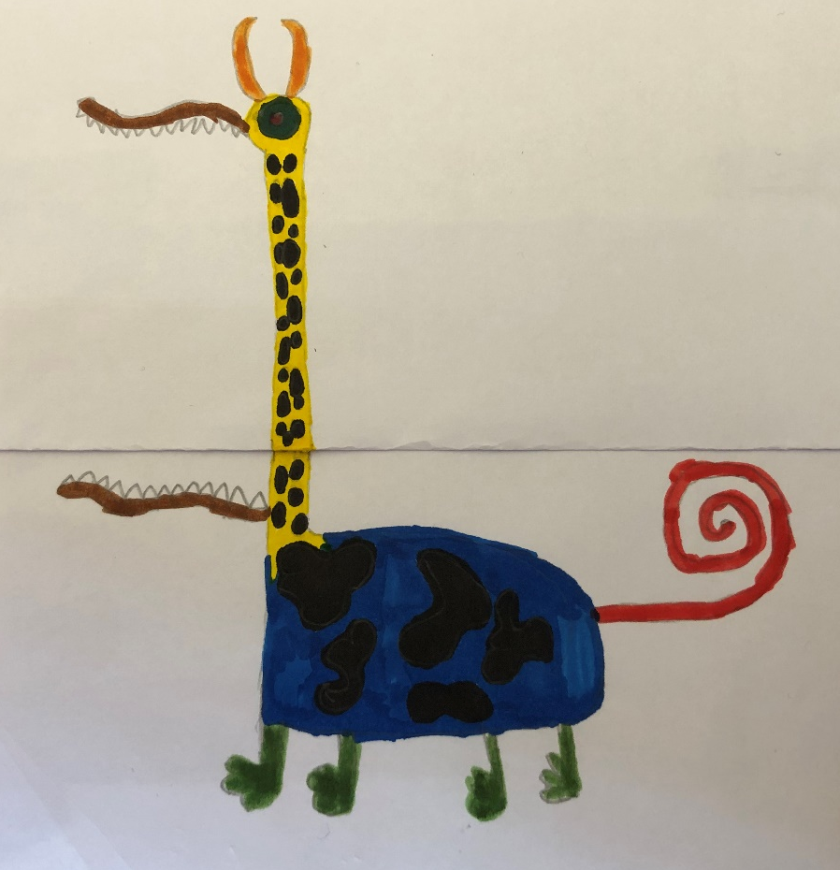

My Miptor is a Croclegrog, his name is Arthur and he is 3 years old. He is a cross between a crocodile and a cow, however he does have some attributes of a frog, a monkey and a giraffe. This is because he has a very diverse family, my mum says Arthur has his uncle’s neck and his grandad’s feet. He was born in the Amazon rainforest and I adopted him when his home was destroyed in a Monsoon. This is my guide to how I look after him.
House
Arthur lives in our garden in a stable. The stable has been adapted for Arthur because he has such a long neck: his head pokes out of a hole in the roof!


Food
Arthur likes to eat fruit and vegetable as he is a herbivore. His favourite food is grapes.
I have a cherry picker in the garden to feed him as he is so tall and can’t bend down to eat because it gives him indigestion. When the cherry picker is broken (which sometimes happens), I feed him with an extendable fishing rod.
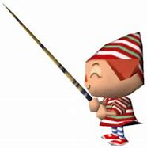
Arthur needs feeding frequently, every 2 hours; basically I am up down in the cherry picker all day!

Hygiene
Because Arthur eats a lot he also does a lot of poops! Cleaning out the stable is a daily and very stinky job. I go in a sweep them up with a dust pan and brush. 
He also needs washing weekly. I wash his face with warm flannel and he really likes cucumber slices on his eyes – he finds it relaxing whilst I wash his face. To wash his body I have an extendable broom which I dip in warm soapy water. He is quote fussy about his soap – he only likes Sanctuary products; he likes the smell!

Health
Exercise is important to Arthur, otherwise he gets fat! His favorite type of exercise is a walk. I take his saddle and tack him up, he needs a head collar and reins so that I can direct him. When he is ready I ride him around the village, I do get some funny looks because he is a little unusual!

Health issues
A common problem with Croclegrogs like Arthur is that they suffer from itchynecktosis; this is an issue when the neck itches like mad because of dry skin. The solution to this is rubbing Sudocrem on his neck before bed.
Because he is so tall (10 m) he is fairly close to the sun, so he gets quite bad sunburn on a bald patch on the top of his head. When I feed him in the morning I rub a little factor 50 sun cream on to this to prevent burning.

Handling
You need to be super careful around Croclegrogs because they can bite if they are annoyed, so it is important to treat them nicely.
It is also very important to remember not to feed him after midnight. I am not sure why, the agent who I bought him from just advised me not to do this. He was a wise man so I am heeding his advice.

