Miptors: The Essential Guide
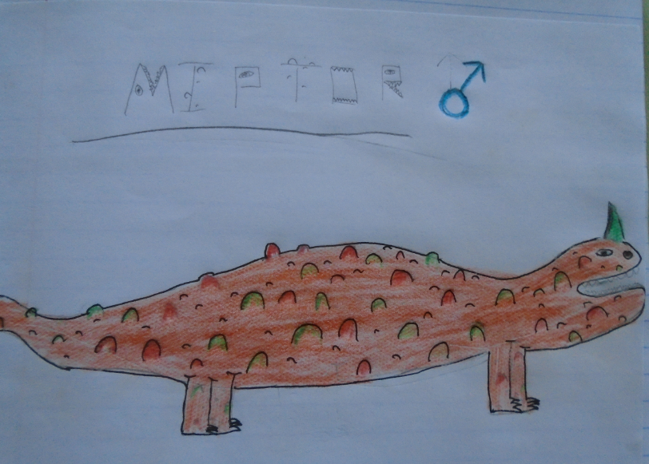
Miptors are the latest trend in pets. These cute creatures, which originate from the Gobi desert, are proving to be the perfect companion for animal lovers everywhere. Everyone from Queen Elizabeth to the Kardashians now have one.
However, before you jump on the miptor-owning bandwagon, there are some ground rules you need to know before becoming a miptor owner. Remember – a miptor is for life – not just for Christmas!
Where should I keep my miptor?
Because miptors are originally from the desert, if you wish to take care of one, it will need to be kept in a sand filled, glass container with a heat lamp in. The miptor will also need a hollowed out hot rock for it to sleep in. Fully-grown miptors can measure from 20cm – 32cm long so you will need to ensure that your miptor’s accommodation is at least 200 x 90 x 120cm in volume ( we recommend Pets at Home for this). A good place to keep your miptor would be on top of a table in sunny spot in your bedroom. Remember – miptors like to sunbathe!
In the wild, miptors live and hunt in pairs therefore, ideally, you should keep two miptors together so they don’t get lonely.
What do I feed my miptor?
Every day, the miptor will need a supply of food every six hours equivalent to half the size of its self which needs to consist of pineapple, bananas and kiwi. Due to it living in a dry, harsh climate, it will need a large supply of water which will need to be refilled every two hours. Under no circumstance feed it any type of meat. The reason for this is that they are strict vegetarians and will get offended and this may lead to them lashing out at you with their sharp claws. Do not underestimate a miptor. The make look cute on the outside but on the inside they become a devil if provoked.
How do I handle my miptor?
Miptors will allow you to handle them – but only when they are in the mood. You will know that it is safe to handle them if their scales are green, not orange. If you wish to handle your miptor, please wrap your fingers around its shoulders softly and slowly otherwise the miptor may get distressed and bite. Holding a miptor with too much force will snap its shoulder bones or crush its ribs. To prevent this, please do not let young children handle a miptor without supervision until they are responsible and at least ten years of age.
How do I keep my miptor fit and healthy?
Miptors are highly active creatures and will needs 4 walks a day - every day – so you need to be prepared for this. They also need their scales to be spiky so they can to fend for themselves therefore you will need to put a pumice stone in their tank so they can rub against it and sharpen them. These scales also help the miptor with both speed and stamina because of their shape as the wind can flow over them creating less resistance. Also, you will need to put a pile of rocks in their tank so that they can escape into the gaps for shade and protection.
What is the best type of miptor for me?
There are many different species of miptor that can be classed as the best for a certain personality. For example, if you’re quite sporty the himnopal miptor is good for you because it likes to run rather than walk. Whereas the volgor miptor is very affectionate and likes snuggles and cuddles. If you are very laid back, I would advise the petrifier miptor whose name is a misnomer because they are not scary at all. In fact they are the most independent of all because they walk themselves so you don’t have to miss the season finale of Tipping Point.

So what are you waiting for? Contact us today so we can help you find your ideal match miptor at www.miptorpet.findyourstoday.co.uk

