How to look after a Miptor

What a Miptor is like

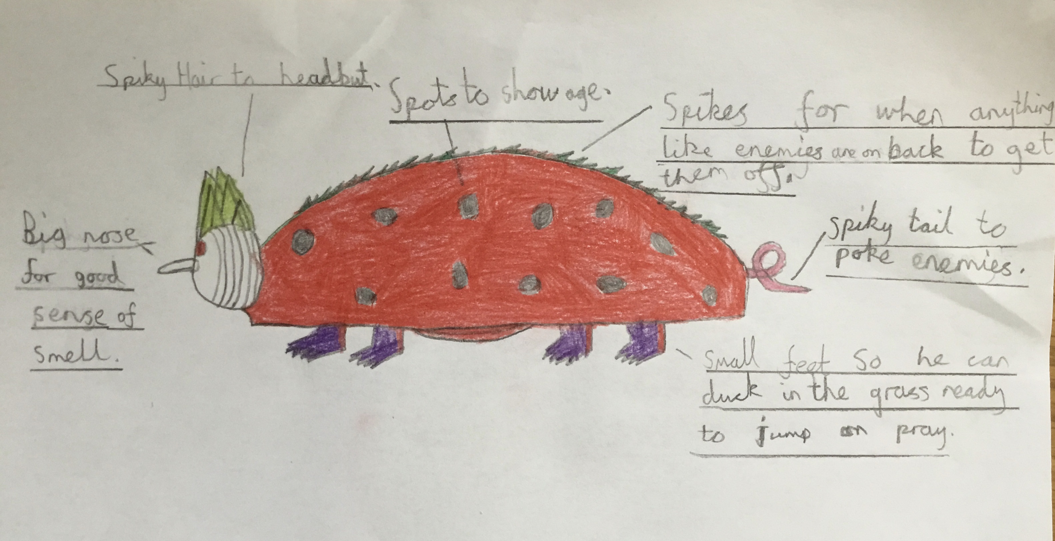
A Miptor is an extraordinary breed of ladybird. It comes from a desert in Egypt. It is very friendly and loving to its owner but not so friendly to strangers so may take a while to get used to a new owner. The miptor likes to spend time at his home with his owner but also likes to go out hunting during the daytime. It has very small feet to be able to duck deep down into the grass and be ready to jump on prey. The Miptor has retractable spikes on different parts of his body to scare off or fight enemies, these also keep him warm outside. The Miptor’s best feature is it’s big nose, he has an excellent sense of smell and can smell things from up to 1 mile away. It’s spots show it’s age- 11 years old, so he is a very old man for a ladybird.

What a Miptor eats
The Miptor eats every 5 hours, even throughout the night! He mostly eats fish and crabs but they have to be alive. He likes snacks of flies and ants that he catches when out hunting. If you touched him while he was eating he would probably bite you so be careful. BEWARE do not let him eat baked beans else the result will be extremely smelly for many days !!!! The Miptor needs half a litre of water to drink every day.

How to take care of a Miptor
When the Miptor is in the house he likes to be kept in warm places, such as near a radiator as his natural habitat is in the desert remember. He also likes to be blown with the hairdryer once a day to make him feel at home!
When you wash a Miptor be careful washing his spots or it may bite you. He needs to be washed every day in a hot bath and handled with care as he is very old.
For exercise and training you should put it on a treadmill to test it’s speed. Put it up to 5 mph and it will be fit in no time.

By Billy-George Burwell

