
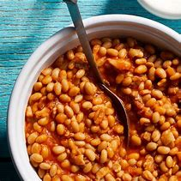
Arlo the Miptor

Arlo the Miptor is a very rare and strange animal which lives at the seaside and only comes out at mid-day when everyone is out at the sea front. He is a crossbreed of bird, tiger, snake, lizard and elephant. His favourite food is chips and beans however he won’t eat his chips if they don’t have lots of salt on them. Arlo’s personality changes depending on the time. If he runs out of beans, he is a very mean animal however if he was had beans for lunch and chips for tea, he is happy, but his overall character is friendly but will always pinch everyone’s food.

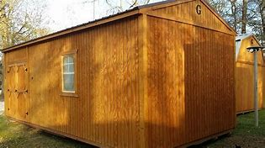
How to take care of Arlo:
If you were to take care of this animal, I suggest you kept him in a cage however it would probably have to have his cage as a shed/garage. If you had him for a day make sure you have lots of beans and/or chips, or you may risk your life. Even though he is very friendly you will be scared of him because of how angry and big this creature looks. He won’t hurt you unless you don’t have chips and/ beans, or you let him free because he will stand on you but not on purpose because he just can’t see where his feet go.

Where does he live:
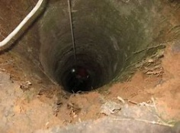
You might be wondering where does this strange odd-looking animal live when he is not at the sea front eating chips. Well I know, he lives somewhere spectacular. Maybe on a roller coaster or in a soft bouncy mat or even a trampoline but no a small, little, old, fragile hole in the ground. But for this big strange animal it has to be enormous not like any hole because he needs his legs too fit and not only that, he doesn’t want people seeing him sleeping.

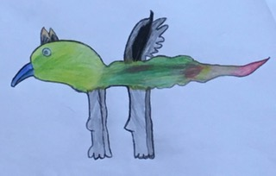
So just remember if you see Arlo make sure you give him a chip and leave him alone.
ARLO

