How bridges are strengthened:
- Triangles
- Arches (like the Romans used)
- Albert cables

Bridges
Types of bridge:
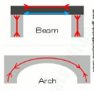 | 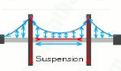  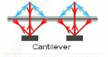

Famous bridges:
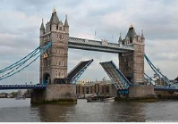 | 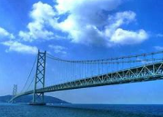
Tower Bridge (London) | Akashi Kaikyo Bridge (Japan)
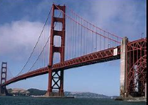 | 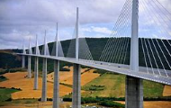
Golden Gate Bridge (USA) | Millau Bridge(France)

What did he build?
 | 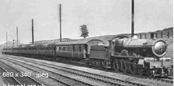
Clifton Suspension Bridge | The Great Western Railway
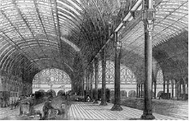 | 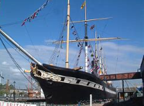
Paddington Station | SS Great Britain

Isambard Kingdom Brunel was a great Victorian engineer who revolutionised transportation.
He designed railways, tunnels, stations, ships and bridges.
Many of his creations are still in use today.

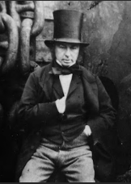
Isambard Kingdom Brunel ( 1806 – 1859)

