School Feedback
"The course has been successful in supporting parents with helping their child read, which is a high priority for our school. Engaging with our parents and developing our role in the wider community is crucial to us as a school and we welcome any opportunities for our children and parents to learn together. The courses are a valuable opportunity for our parents to engage in the learning of their children and access a variety of opportunities to develop their own learning.
Fun with Reading–Market Rasen CofE Primary School

"It has become part of the DNA of the school. We deliver sustainability courses in the child's reception year and therefore, due to effective recruitment, are able to recruit and engage parents more readily into the Family English programme when their child enters Year 1. The Family English course enables us to send key messages regarding specific skills e.g. phonics which facilitates effective learning opportunities at home."
Family English, The Magdalen C of E / Methodist School.

Very evident wthin the wider school community that mental health and wellbeing is becoming an increasingly important factor. This course covered many different aspects and supported parents well when it comes to these issues for themselves and their children. Sara was great at supporting all learners of varying abilities.
Lets be happy and healthy – Tydd St Mary
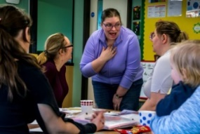

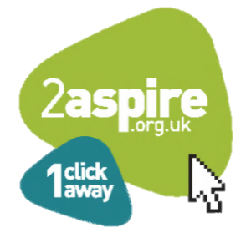



'Leaders and managers have worked tirelessly to promote a positive culture across the council that celebrates learning, achievement and social inclusion'
OFSTED 2019

Contact Details
Family Learning is part of the Adult Skills and Family Learning Service and is delivered out of the Learning Office in Sleaford. Please find below our contact details:
Adult Skills and Family Learning Team
Enterprise, Growth and Learning
Lincolnshire County Council
Sleaford Area Office
Office 2 Sleaford
Lincolnshire
NG34 7EB

Email: BS_LearningLH@lincolnshire.gov.uk

Tel: 01522 782011
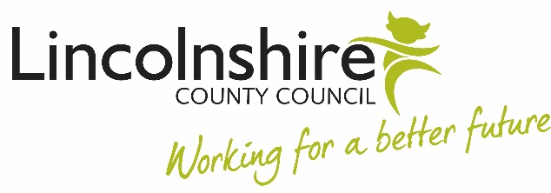

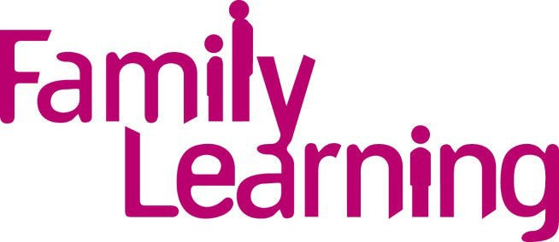

in Lincolnshire 2021/22

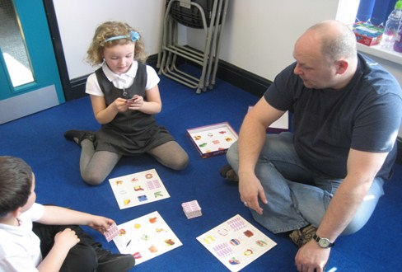
(Fun with Numbers)

What is Family Learning?

Family Learning is a national programme established to help parents and carers support their child’s learning whilst improving their own English and/or Maths skills.

We can offer a wide range of quality courses, which are delivered by a team of trained professionals.

Family Learning gives parents/carers the chance to learn new skills and support their child’s learning in a fun and friendly way.

Why Family Learning?
Family Learning successfully engages with hard to reach learners because the emphasis is placed on supporting their children rather than explicitly addressing a learning need, developing constructive parent-school relationships.

Parents gain positive benefits from the courses. They enjoy the time they can spend with their children away from the pressures of family life and many gain an understanding of how modern schools work, and how English and maths are taught.

Having participated in the courses, many of the parents have gone on to work in schools as supervisors, teaching assistants, reading volunteers and parent helpers. Some parents have also gone on to become school governors.
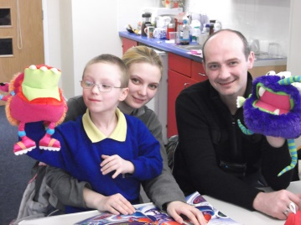

Benefits to Participating Schools

Meets OFSTED requirements through engaging parents in supporting pupils' achievement, behaviour and their spiritual, moral, social and cultural development.

- Proven to help improve children’s attainment.

- Improves partnerships between parents and their child's school.

- 'Learners develop excellent employability and personal and social skills' OFSTED 2019

- Fully funded by the Education & Skills Funding Agency through Lincolnshire County Council.

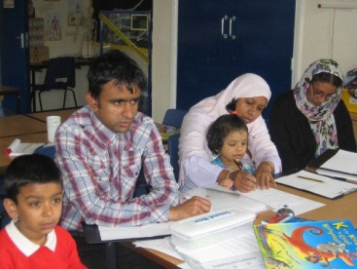

(Family ESOL)

Family Learning Courses
There are a variety of courses provided by Family Learning in Lincolnshire. Courses can be adapted according to school requirements.

A course can be between 6 –12 weeks depending on the subject. A session is between 2–3 hours depending on the length of the course.

A taste of the courses available are listed below:
Lets' Be Happy and Healthy
Let's Talk for EAL Parents and carers
Keeping Up With The Children maths/English
You and your Child Working Together
Healthy Living and Family Wellbeing
Story Sacks and Phonics
Learning Through Play
Supporting your child with Learning at Home
Sustainability – Arts and Crafts
Sustainability – Feed Your Family on a Fiver
Sustainability – Grow Your Own
Sustainability - Family Fun Outdoors

All our courses are fully funded

