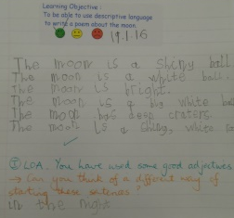
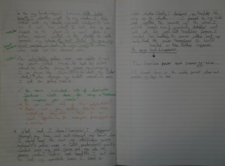
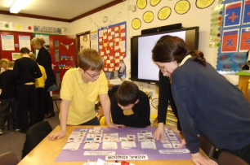





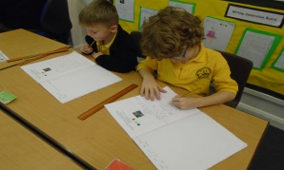

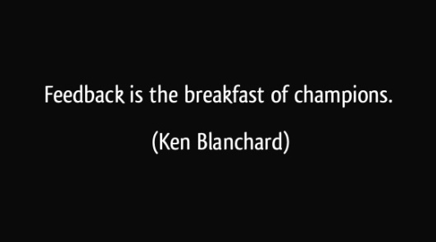


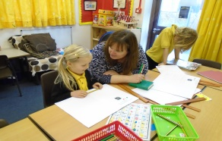
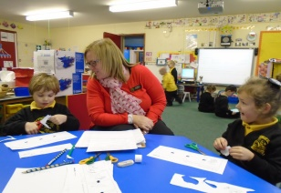

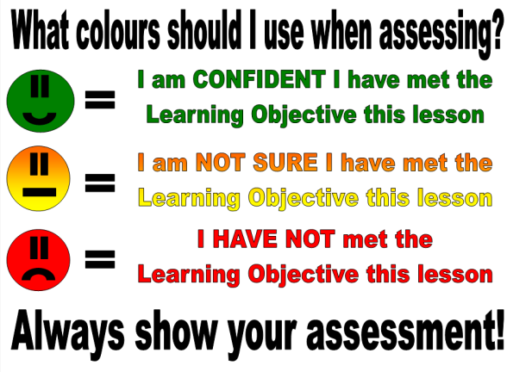
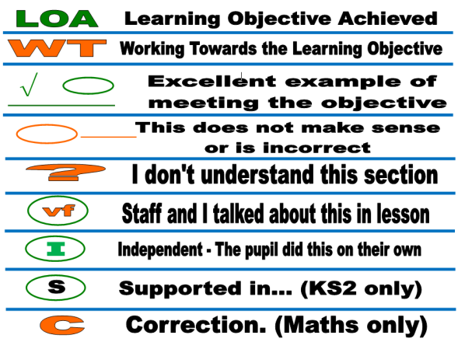
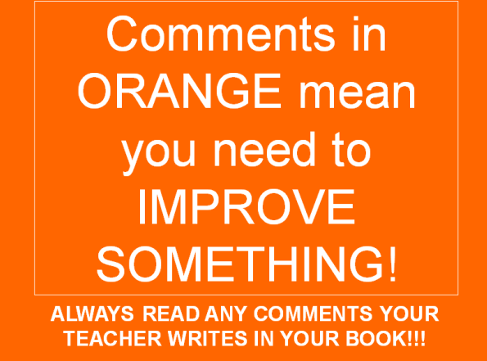
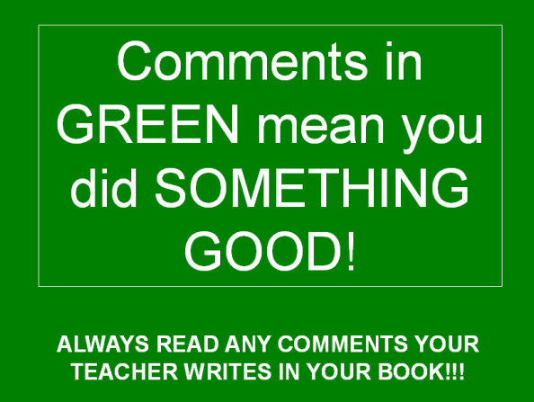
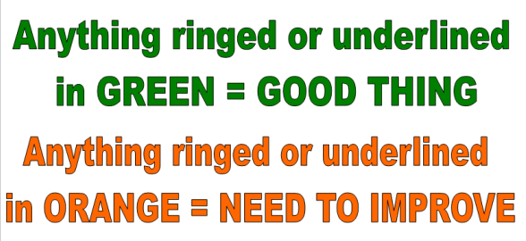
Partners
www.quadringprimary.co.uk
Tel: 01775 820302
Principles of Good Marking
Good marking or annotation of children’s work should:
- Be positive, motivating and constructive,
- Be at the child’s level of comprehension,
- Not penalise children’s attempts to expand their vocabulary,
- Be written in handwriting that is legible and a model for the child, ensuring that the sentences are punctuated correctly with capital letters and full stops.
- Be frequent and regular,
- Provide information for the teacher on the success of the teaching,
- Relate to the Learning Objective of the lesson set but also relate to basic skills in English linked to handwriting and spelling,
- Positively affect the child’s progress,
- Contain comments from the teacher which are particularly focused and diagnostic revealing very good subject knowledge,
- Be accessible to all,
- Relate to literacy targets in all written pieces particularly those linked to basic skills,
- Ensure children can actively demonstrate understanding of targets set,
- Be consistent in all areas, throughout the school

Quadring Cowley and Brown’s Primary School Marking and Feedback brochure
Monitoring and Evaluation
Members of the Senior Leadership Team will review samples of work from each class to monitor the implementation of this policy.

An analysis will be made and feedback given to staff. The desired outcomes for this policy are improvement in children’s learning and greater clarity amongst children and parents concerning children’s achievements and progress.

The Performance Indicators will be:
- An improvement in children’s attainment.
- Consistency in teachers marking across the key stages and between year groups.

One final note
We hope you find this leaflet useful on how we mark and feedback to our pupils at Quadring Primary School. Should you have any further questions, please do not hesitate to speak to your class teacher or head teacher during Parents Evening, Open Evening or at the end of the school day.

Rationale

Quadring Cowley and Brown’s Primary School is committed to providing relevant and timely feedback to pupils, both orally and in writing.

Marking intends to serve the purposes of valuing pupils’ learning, helping to diagnose areas for development or next steps, and evaluating how well the learning task has been understood.

Marking should aim to be a process of creating a dialogue with the learner, through which feedback can be exchanged and questions asked; where the learner is actively involved in the process. Research shows that marking is the most important factor in pupil learning, so this policy is crucial for the school.

‘Imagine what a difference it would make if all children knew what they were good at and knew what they needed to do to improve’.

Aims

We aim to:
- Assess children’s learning,
- Take learning forward,
- Provide consistency and continuity in marking throughout the school so that children have a clear understanding of teacher expectations,
- Use the marking system as a tool for formative on-going assessment
- Improve standards by encouraging children to give of their best and improve on their last piece of work
- Develop children’s self-esteem through praise and valuing their achievements
- Create a dialogue which will aid progression

All teachers will adhere to the principles of good marking and will:
- Provide regular written and oral feedback
- Provide time in lessons to review work from previous lessons
- Adjust planning in the light of marking
- Make learning objectives explicit
- Involve children in the process from an early stage
- Ensure children are clear about the teachers expectations
- Use children’s work as exemplars
- Inform future individual target setting
- Allow specific time for children to read, reflect and respond to the marking and feedback given

Peer Marking and Assessment
We recognise that the following are important points to consider when getting the children to mark their work collaboratively:
- Children need to be trained to do this, through modelling with the whole class and watching paired marking in action.
- Ground rules need to be set (e.g. listening, interruptions, confidentiality, etc.).
- Children should, alternately, point out what they like first, using the highlighter pen, and then suggest ways to improve the piece, but only against the learning intentions and not spellings, etc.
- Pairings should generally be ability based and where appropriate could be ‘Learning Partners’ (e.g. two middle, two higher or one middle and one lower together.)

What colours do we mark in and what does it mean?
All classrooms have the following displayed so all children and staff can see clearly. This is our marking policy and explains what to look for in books and why. This system, based upon the Shirley Clarke method of assessment, is designed to make marking clearer. Introduced back in 2011, this is now ingrained into Quadring life and used not only in pupil’s books, but also in lesson observation feedback, subject scrutinies and performance management!

Codes
Like the colours, the following are explained in every classroom and is designed to be a record for all pupils and staff to understand the precise feedback given.

Robins, Eagles and Owls all have Learning Objective strips with specific aims and guidance glued into their books for every lesson with these codes.

Expectations of our pupils
All pupils are expected to engage with marking and feedback. Dependent upon their age, will be how much they engage with it.

Our Key Stage 2 students (Years 3/4 and 5/6) are expected to self or peer assess every piece of work against the learning Objective and demonstrated how successful they have been by circling/highlighting evidence if Success Criteria in their work.
Our Key Stage 1 students (Years 1/2) are expected to self-assess 80-90% of their work and peer assess 10% through the use of smiley faces (see diagram).

By introducing this level of assessment, our children are beginning the assessment process in which dialogue between pupil and teaching can take place concerning achievement and progression.

How effective is Feedback?
According to the Education Endowment Fund (EEF) Toolkit, feedback studies tend to show very high effects on learning. However, it also has a very high range of effects and some studies show that feedback can have negative effects and make things worse. It is therefore important to understand the potential benefits and the possible limitations of the approach. In general, research-based approaches that explicitly aim to provide feedback to learners, such as Bloom’s ‘mastery learning’, tend to have a positive impact. Feedback has effects across all age groups. Research in schools has focused particularly on its impact on English, mathematics and, to a lesser extent, science.

Research evidence about feedback was part of the rationale for Assessment for Learning (AfL). One evaluation of AfL indicated an impact of half of a GCSE grade per student per subject is achievable, which would be in line with the wider evidence about feedback.

Sampling and Scrutiny
The Senior Leadership Team and Subject
Leaders will conduct book sampling at least once every term to assess the impact of marking and feedback on learning. Additionally, pupils will be consulted on how effective they find feedback from their teachers which will then able us to measure this individual progress. Work in Years 2 and 6 is regularly monitored by fellow professionals from other schools and we constantly strive to study best practise in this field to enhance the marking and feedback process.

