

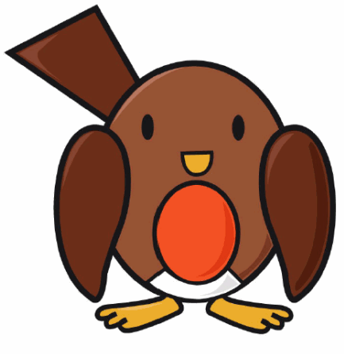
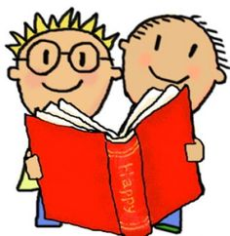






End of Year Expectations for Years 1 & 2 – Robins Class in Reading, Writing and Maths
Partners
www.quadringprimary.co.uk
Tel: 01775 820302
Reading Expectations at the end of Year 1

- Identify which words appear again and again.
- Relate reading to own experiences.
- Re-reads if reading does not make sense.
- Re-tell with considerable accuracy.
- Discuss significance of title & events.
- Make predictions on basis of what has been read.
- Make inferences on basis of what is being said & done.
- Reads with pace & expression, i.e. pause at full stop; raise voice for question
- Knows difference between fiction and non-fiction texts.

Mathematics expectations at the end of Year 2

- Compare & order numbers up to 100.
- Read & write all numbers to 100 in digits & words.
- Say 10 more/less than any number to 100.
- Count in multiples of 2, 3 & 5 & 10 from any number up to 100.
- Recall & use multiplication & division facts for 2, 5 & 10 tables.
- Recall & use +/- facts to 20.
- Derive & use related facts to 100.
- Recognise PV of any 2-digit number.
- Add & subtract:
  - 2-digit nos & ones
  - 2-digit nos & tens
  - Two 2-digit nos
  - Three 1-digit nos
- Recognise & use inverse (+/-).
- Calculate & write multiplication & division calculations using multiplication tables.
- Recognise & use inverse (x/÷).
- Recognise, find, name & write 1/3; 1/4; 2/4; 3/4.
- Recognise equivalence of simple fractions.
- Tell time to five minutes, including quarter past/to.

Welcome

This booklet provides information for parents and carers on the end of year expectations for children in Robins Class, Years 1 and 2 in our school.
We, as a staff, have identified these expectations as being the minimum requirements your child must meet in order to ensure continued progress throughout the following year.
All the objectives will be worked on throughout the year and will be the focus of direct teaching. Any extra support you can provide in helping your children to achieve these is greatly valued.
If you have any queries regarding the content of this booklet or want support in knowing how best to help your child, please come and talk to us.

Thank you,

S. Gowers Class Teacher

C. Marshall Class Teacher

J. Kelwick Head teacher
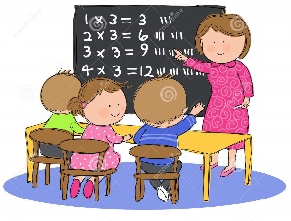
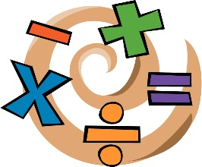


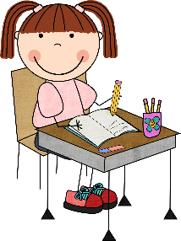

Reading Expectations at the end of Year 2

- Read ahead to help with fluency & expression.
- Comments on plot, setting & characters in familiar & unfamiliar stories.
- Recounts main themes & events.
- Comments on structure of the text.
- Use commas, question marks & exclamation marks to vary expression.
- Read aloud with expression & intonation.
- Recognise:
  - speech marks
  - contractions
- Identify past/present tense.
- Use content and index to locate information.

Writing expectations at the end of Year 1

- Write clearly demarcated sentences.
- Use ‘and’ to join ideas.
- Use conjunctions to join sentences (e.g. so, but).
- Use standard forms of verbs, e.g. go/went.
- Evidence of:
- Capital letters.
- Full stops.
- Question marks.
- Exclamation marks.
- Use capital letters for names & personal pronoun ‘I’.
- Write clearly sequenced sentences.
- Correct formation of lower case – finishing in right place.
- Correct formation of capital letters.
- Correct formation of digits.

Writing expectations at the end of Year 2

- Write different kinds of sentence: statement, question, exclamation, command.
- Use expanded noun phrases to add description & specification.
- Write using subordination (when, if, that, because).
- Correct & consistent use of present tense & past tense.
- Correct use of verb tenses.
- Correct & consistent use of:
- Capital letters.
- Full stops.
- Question marks.
- Exclamation marks.
- Commas in a list.
- Apostrophe (omission).
- Introduction of speech marks.
- Write under headings.
- Evidence of diagonal & horizontal strokes to join handwriting.

Mathematics expectations at the end of Year 1

- Count to & across 100, forwards & backwards from any number.
- Read & write numbers to 20 in digits & words.
- Read & write numbers to 100 in digits.
- Say 1 more/1 less to 100.
- Count in multiples of 1, 2, 5 & 10.
- Know bonds to 10 by heart.
- Use bonds & subtraction facts to 20.
- Add & subtract 1 digit & 2 digit numbers to 20, including zero.
- Add any three 1-digit numbers with a total up to 20.
- Solve simple multiplication & division with apparatus & arrays.
- Recognise half and quarter of object, shape or quantity.
- Sequence events in order.
- Use language of day, week, month and year.
- Tell time to hour & half past.

