








End of Year Expectations for Years 5 & 6 – Barn Owls Class in Reading, Writing and Maths
Partners
www.quadringprimary.co.uk
Tel: 01775 820302
Reading Expectations at the end of Year 5

- Summarises main points of an argument or discussion within their reading & makes up own mind about issue/s.
- Can compare between two texts.
- Appreciates that people use bias in persuasive writing.
- Appreciates how two people may have a different view on the same event.
- Draw inferences and justify with evidence from the text.
- Varies voice for direct or indirect speech.
- Recognise:
  - clauses within sentences
- Uses more than one source when carrying out research.
- Creates set of notes to summarise what has been read.

Mathematics expectations at the end of Year 6

As Year 5 but also…

- Compare & order numbers up to 10000000.
- Identify common factors, common multiples & prime numbers.
- Round any whole number to a required degree of accuracy.
- Multiply:
  - 4-digit by 2-digit
- Divide:
  - 4-digit by 2-digit
- Add & subtract fractions with different denominators & mixed numbers.
- Multiply simple pairs of proper fractions, writing the answer in the simplest form.
- Divide proper fractions by whole numbers.
- Calculate % of whole number.

Welcome

This booklet provides information for parents and carers on the end of year expectations for children in Barn Owls Class, Years 5 and 6 in our school.
We, as a staff, have identified these expectations as being the minimum requirements your child must meet in order to ensure continued progress throughout the following year.
All the objectives will be worked on throughout the year and will be the focus of direct teaching. Any extra support you can provide in helping your children to achieve these is greatly valued.
If you have any queries regarding the content of this booklet or want support in knowing how best to help your child, please come and talk to us.

Thank you,

L. Wood Class Teacher

J. Kelwick Head teacher
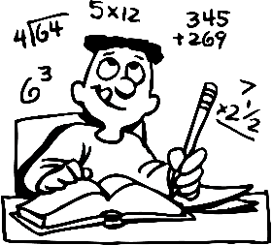
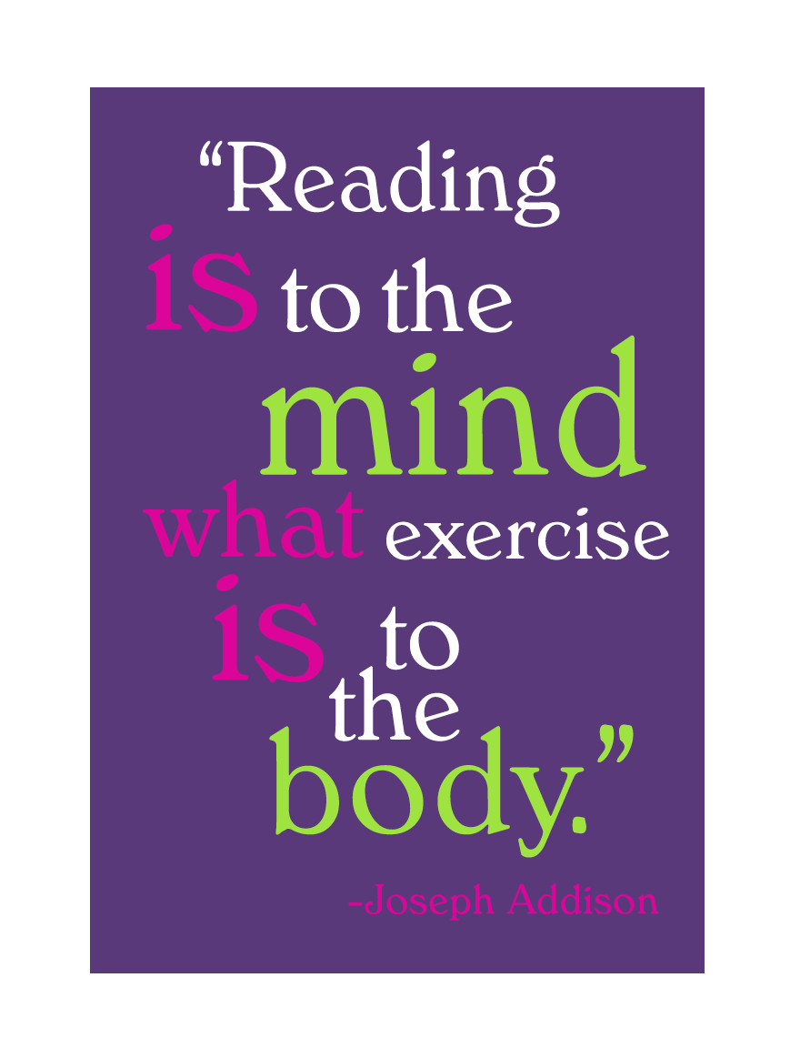

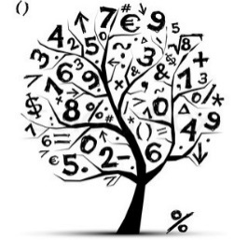
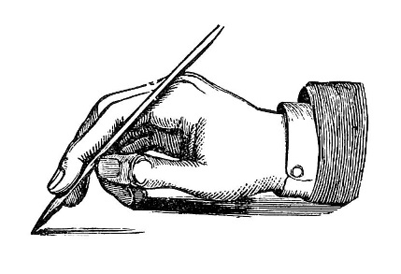
Reading Expectations at the end of Year 6

As Year 5 but also…
- Refers to text to support opinions and predictions.
- Gives a view about choice of vocabulary, structure etc.
- Distinguish between fact & opinion.
- Appreciates how a set of sentences has been arranged to create maximum effect.
- Recognise complex sentences
- Skims and scans to aide note-taking.

Writing expectations at the end of Year 5

- Add phrases to make sentences more precise & detailed.
- Use range of sentence openers – judging the impact or effect needed.
- Begin to adapt sentence structure to text type.
- Use pronouns to avoid repetition.
- Use:
- Brackets.
- Dashes.
- Commas.
- Use commas to clarify meaning or avoid ambiguity.
- Link clauses in sentences using a range of subordinating & coordinating conjunctions.
- Use verb phrases to create subtle differences (e.g. she began to run).
- Consistently organize into paragraphs.
- Link ideas across paragraphs using adverbials of time (e.g. later), place (e.g. nearby) and number (e.g. secondly).
- Legible and fluent handwriting style.

Writing expectations at the end of Year 6

- Use subordinate clauses to write complex sentences.
- Use passive voice where appropriate.
- Use expanded noun phrases to convey complicated information concisely (e.g. The fact that it was raining meant the end of sports day).
- Evidence of sentence structure and layout matched to requirements of text type.
- Use:
  - Semi-colon, colon, dash to mark the boundary between independent clauses.
  - Correct punctuation of bullet points.
  - Hyphens to avoid ambiguity.
  - Full range of punctuation matched to requirements of text type.
- Use wide range of devices to build cohesion within and across paragraphs.
- Use paragraphs to signal change in time, scene, action, mood or person.
- Legible, fluent and personal handwriting style.

Mathematics expectations at the end of Year 5

- Count forwards & backward with positive & negative numbers through zero.
- Count forwards/backwards in steps of powers of 10 for any given number up to 1000000.
- Compare & order numbers with 3 decimal places.
- Read Roman numerals to 1000.
- Identify all multiples & factors, including finding all factor pairs.
- Use known tables to derive other number facts.
- Recall prime numbers up to 19.
- Recognise PV of any number up to 1000000.
- Round any number up to 1000000 to the nearest 10, 100, 1000, 10000 or 100000.
- Round decimals with 2dp to nearest whole number & 1dp.
- Add & subtract:
  - Numbers with more than 4-digits using efficient written method (column).
  - Numbers with up to 2dp.
- Multiply:
  - 4-digits by 1-digit/ 2-digit
- Divide:
  - 4-digits by 1-digit
- Multiply & divide:
  - Whole numbers & decimals by 10, 100 & 1000
- Count up/down in thousandths.
- Recognise mixed numbers & fractions & convert from one to another.
- Multiply proper fractions by whole numbers.
- Solve time problems using timetables and converting between different units of time.

