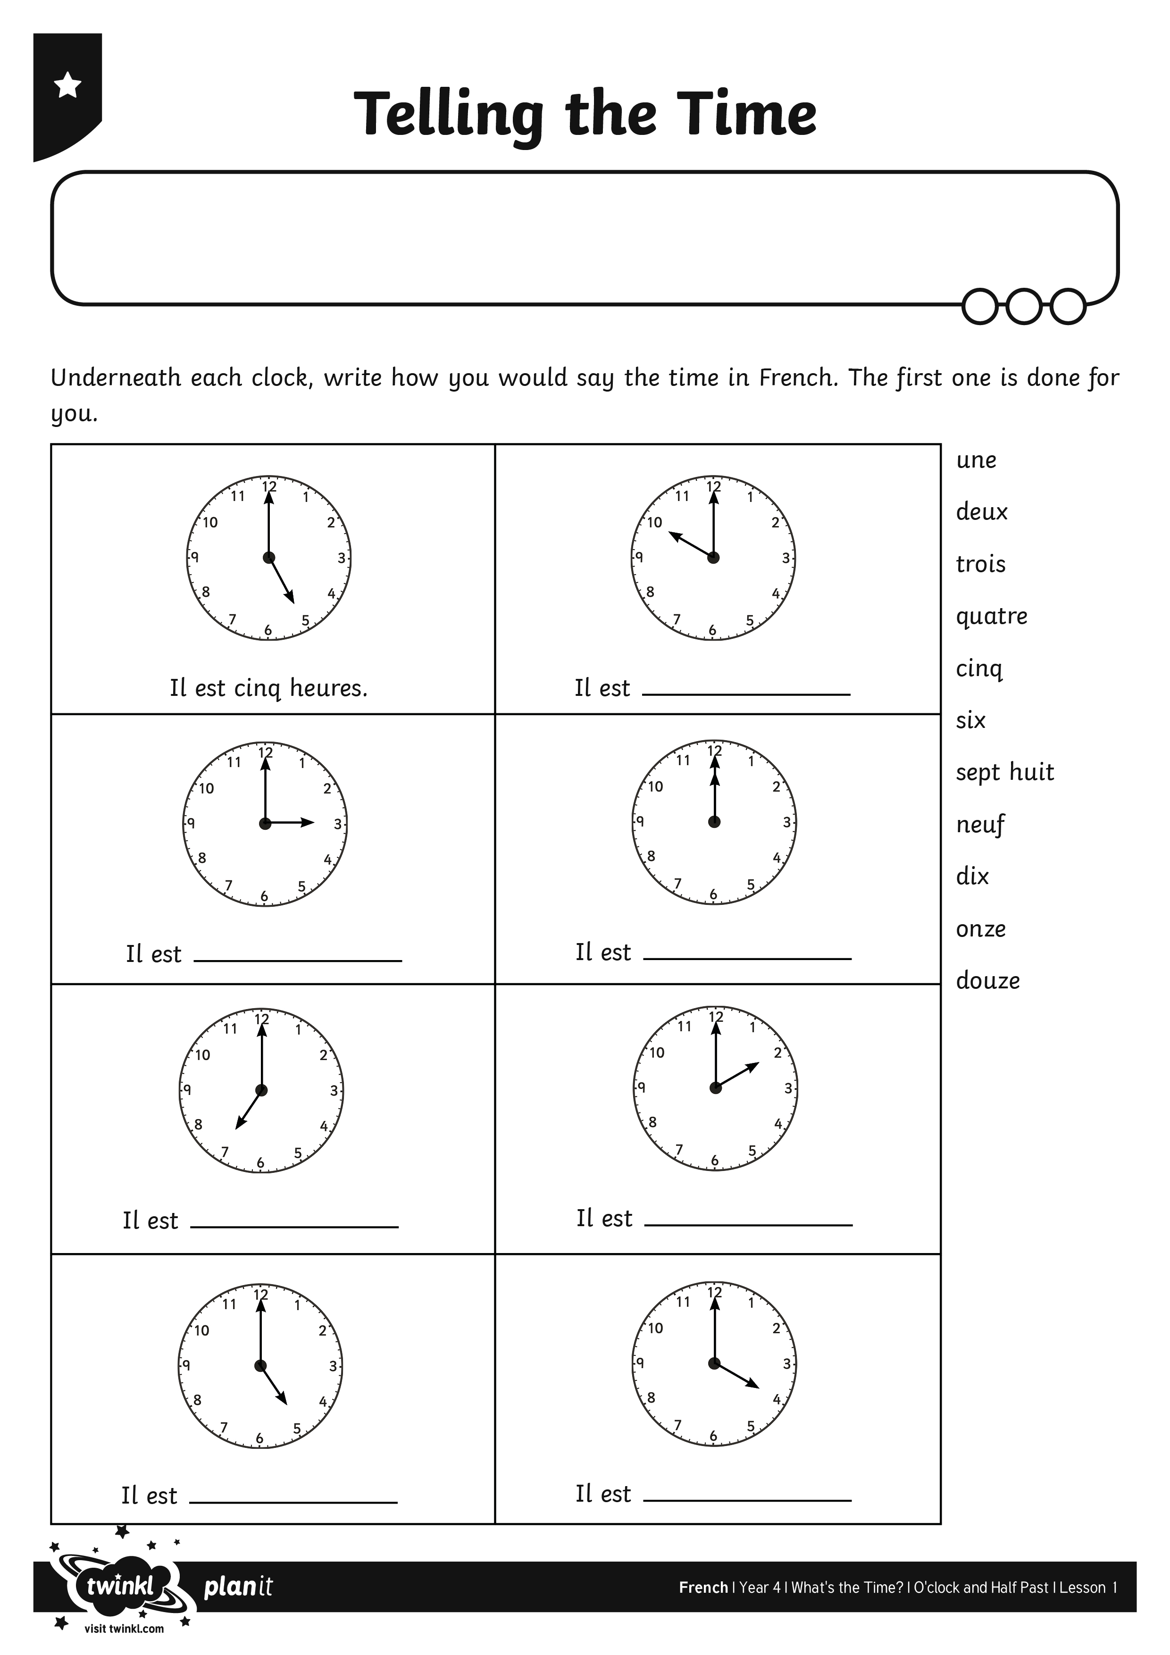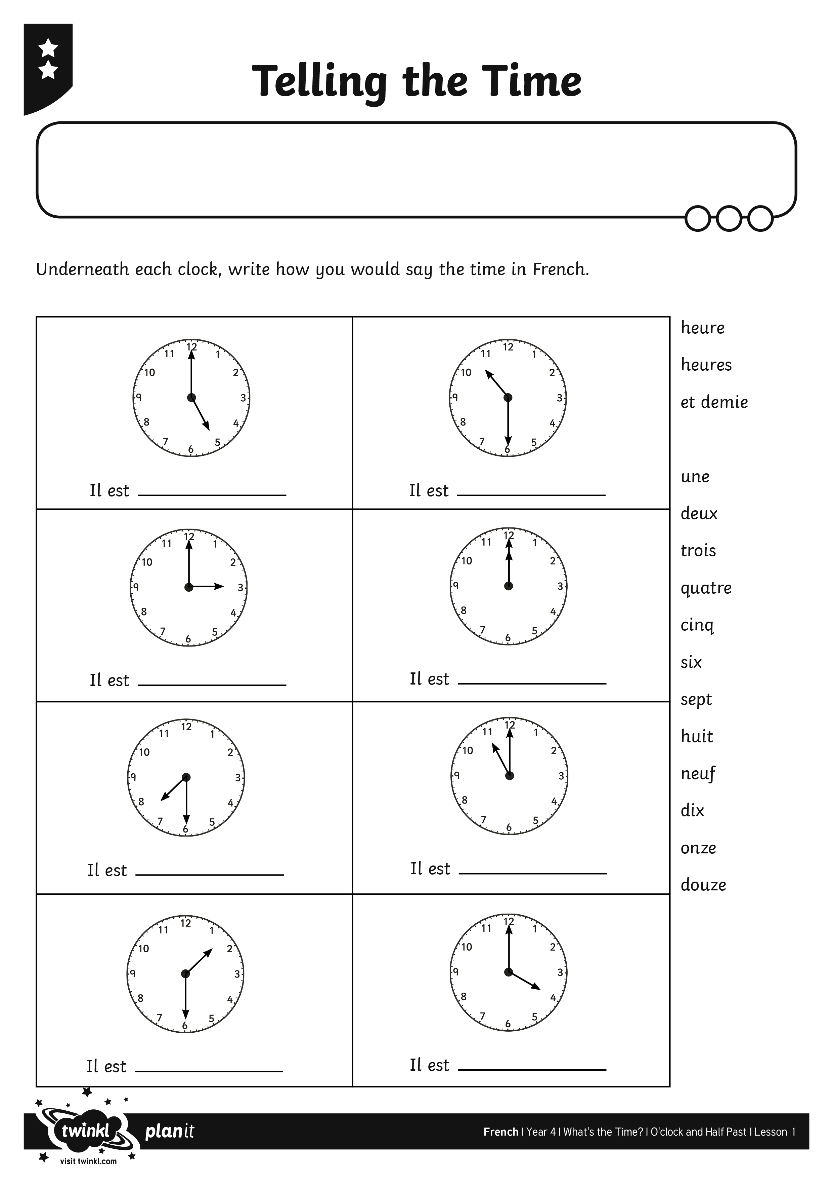
I can write a sentence to tell the time – o’clock.
I can write a sentence to tell the time – o’clock.

