
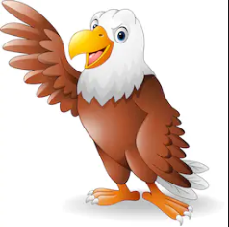
Geography
UK Countries, counties and cities
Physical and human features
Compass points
Using different types of map
R.E
Christianity (God)

P.E
Swimming
Gymnastics
British art and artists
Cartography

Science
Living things and their habitats
-is it living?
- plants
- invertebrates
-fish and amphibians
-birds and reptiles
-mammals

Times Tables
6 times tables
7 times tables
9 times tables
Review all

SMSC
Managing emotions

Grammar
Fronted adverbials
Commas for lists
Past and present tense
Determiners
Prepositions
Headings/subheadings
Spelling
Revision of common exception words
Apostrophes

Music
Times tables songs
Traditional music from around the UK
Computing
Internet safety
Email
DT
Traditional British dishes
English
- holiday brochure (UK topic)
- Performance Poetry
- Postcards – UK
- Information writing – Habitats

Golden Eagles
Term 3
The UK
Maths
Fractions
Mass and Capacity

