Finding multiples of 10%
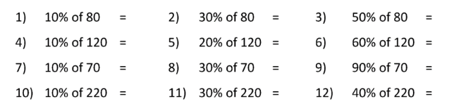

Finding multiples of 1%
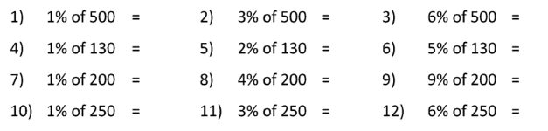
Mixed


