Q1. An aeroplane takes off on Tuesday at 22:47
It lands on Wednesday at 07:05
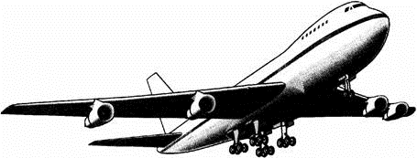
How long in hours and minutes is the flight?

hours minutes

1 mark

Q2. The clock shows the same time as one of the watches.
Draw a line to match the clock to a watch.
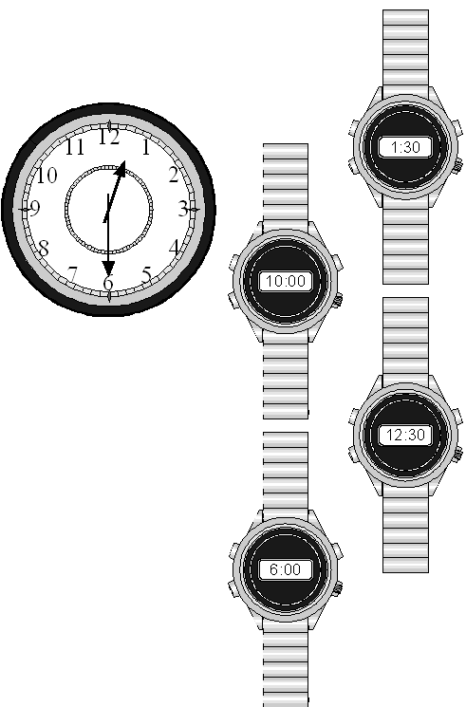
1 mark

Q3. The time is 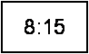
John has to be ready for school in half an hour.
Tick () the time when he has to be ready.
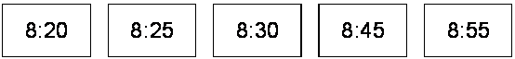
1 mark
Q4. Jodie has to be at the dentist at half past nine.
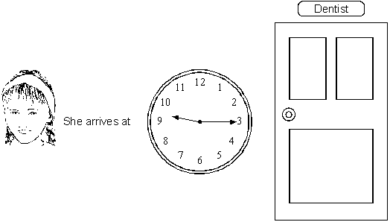
How many minutes early is she?

minutes

1 mark

Q5.
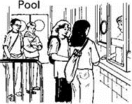
These are the opening times at a swimming pool.
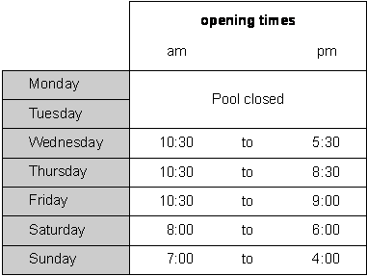
How many hours is the pool open on a Sunday?

hours

1 mark

Which day has the latest closing time?

...............................
1 mark

Habib arrives at the pool at 5:20pm on Saturday.
How many minutes is it before the pool closes?

minutes

1 mark
Q6. Here are three clock faces.
Match each clock face to the same time on a digital clock.
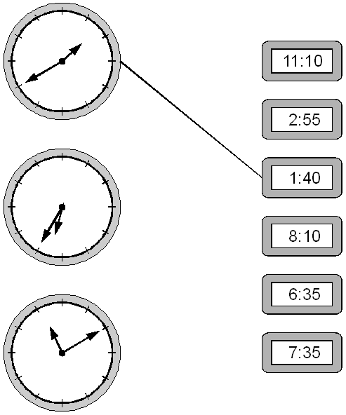
2 marks
Q7.

Boat Hire
Motor boats  £1.50 for 15 minutes | Rowing boats  £2.50 for 1 hour

How much does it cost to hire a rowing boat for three hours?

£

1 mark
Sasha pays £3.00 to hire a motor boat.
She goes out at 3:20 pm.
By what time must she return?

pm

1 mark
Q8. This was the time on Selin’s watch when she set off for a walk.
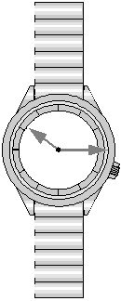
What time did the watch show 20 minutes before this?

1 mark
What time did it show an hour and a half after she set off for the walk?

1 mark
Q9. Jack leaves for school at this time.
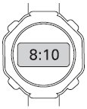
It takes him 40 minutes to get to school.
Tick () the time Jack gets to school.
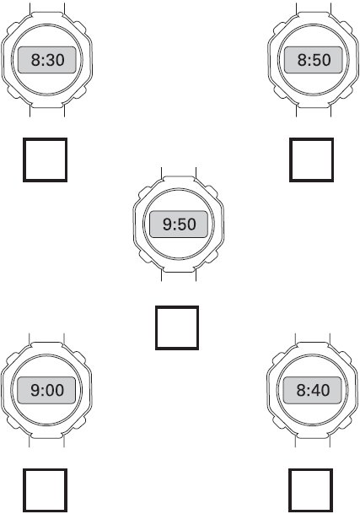
1 mark
Q10. Here is part of a calendar.
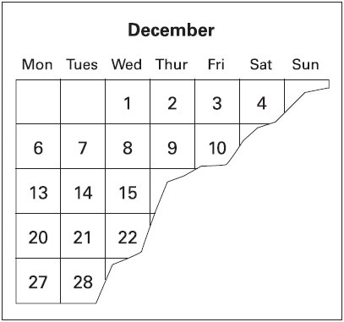
Tyrone’s birthday is on December 18th.
On what day of the week is Tyrone’s birthday?
1 mark
Q11. These clocks show the start and finish times of a TV programme.
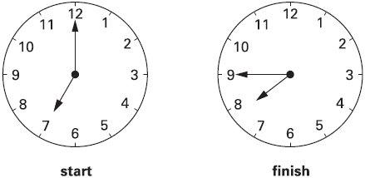
For how many minutes does the programme last?

minutes

1 mark

Q12.
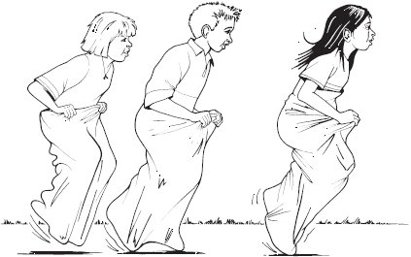
The Fun Day started at this time in the morning.
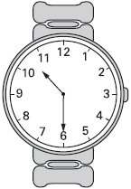
It finished at this time in the afternoon.
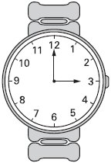
How long did the Fun Day last?

hours minutes

1 mark

Q13. Two clocks show the same time.
Tick () them.
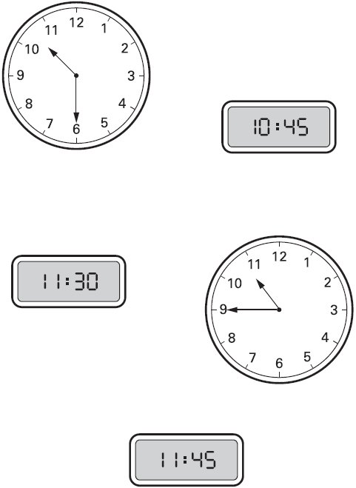
1 mark
Q14. Here is a clock.
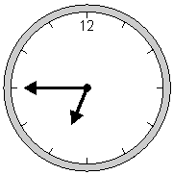
How many minutes is it until this clock shows 7:30?

minutes

1 mark

Here is another clock.
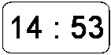
What time will the clock show in 20 minutes?

1 mark
Q15. Match each clock to the correct time.
One has been done for you.
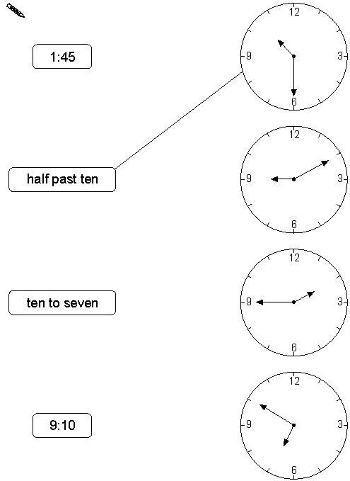
1 mark

Q16.
These are the radio programmes one morning.

7:00 Music show
7:55 Weather report
8:00 News
8:15 Travel news
8:25 Sport
8:45 Holiday programme

Josh turns the radio on at 7:25 am.
How many minutes does he have to wait for the Weather report?
minutes

1 mark
The Holiday programme lasts for 40 minutes.
At what time does the Holiday programme finish?
am

1 mark
Q17. A clock shows this time.
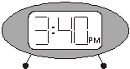
How long is it from this time until 5pm?

1 mark
What time was it quarter of an hour before the time on the clock?
pm

1 mark

Q18. The time is 10:35am.
Kate says,
‘The time is closer to 11:00am than to 10:00am’.
Explain why Kate is correct.

1 mark
Q19. Jamie makes a time line of part of his day.
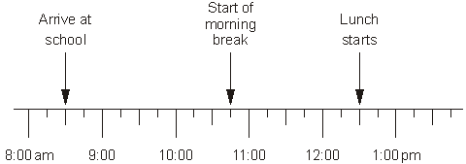
What time does Jamie’s morning break start?

am

1 mark
Lunch lasts for three-quarters of an hour.
What time does lunch finish?

pm

1 mark
Q20. Here are two clock faces.
Join each clock face to the correct digital time.
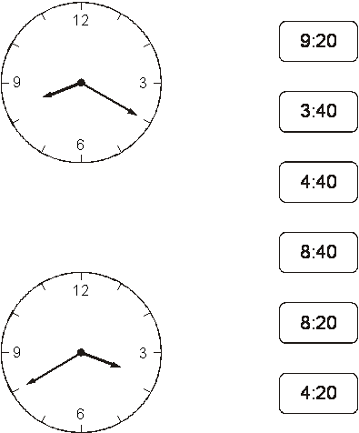
2 marks

Q21. Put these times in order, starting with the shortest.
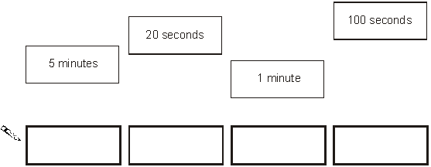
shortest
1 mark

Q22. Circle the time that is 30 minutes before midnight.
12:30 am 12:30 pm
11:30 am 11:30 pm 3 am
1 mark
Q23. This table shows the opening times of a pet clinic.
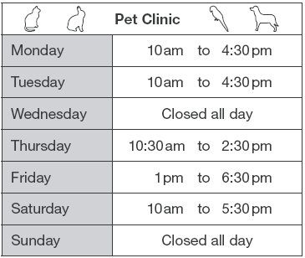
How many hours is the clinic open on Thursday?

hours

1 mark
On which day is the clinic open for the longest time?
........................................
1 mark
Liam takes his dog to the clinic on Saturday.
He arrives at 9:25am.
How many minutes is it before the clinic opens?
minutes

1 mark

Q24. Write these times in order, starting with the shortest.
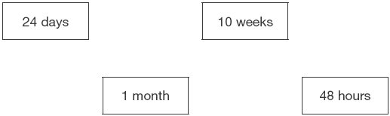

shortest

1 mark
Q25.
Holly takes half an hour to walk from home to school.
She arrives at school at 8:25am.
At what time did she leave home?

am

1 mark

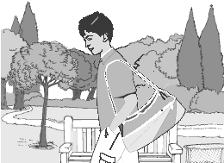
Dev leaves school at half past three.
He arrives home at ten past four.
How many minutes did it take him to get home?

minutes

1 mark
Q26.These are the opening times at Black Tower Castle.

 | Monday | Closed
 | Tuesday to Friday | 11am to 6:30pm
 | Saturday | 10am to 6pm
 | Sunday | 10:30am to 4:30pm

How many hours is the castle open on Saturdays?

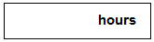
1 mark
Alfie arrived at the castle at 5pm on a Thursday.
How long could he stay before closing time?

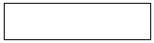
1 mark

