A. Cast fossil of the skull of the dinosaur Massospondylus.
Massospondylus had a small head and long, sharp teeth. Its body was around 5 metres long. It is believed to have lived 200,000,000 years ago.
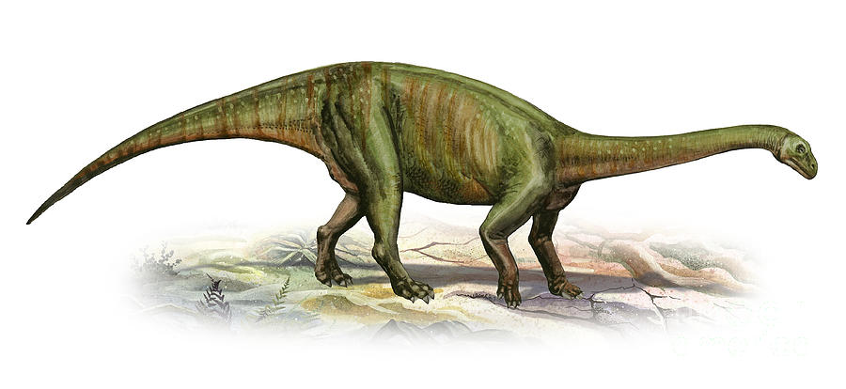

B. Cast fossil of eggs laid by the dinosaur Torvosaurus.
Torvosaurus was a hunting dinosaur that lived around 148,000,000 years ago.
Its arms were short with sharp claws and it walked on two powerful legs.

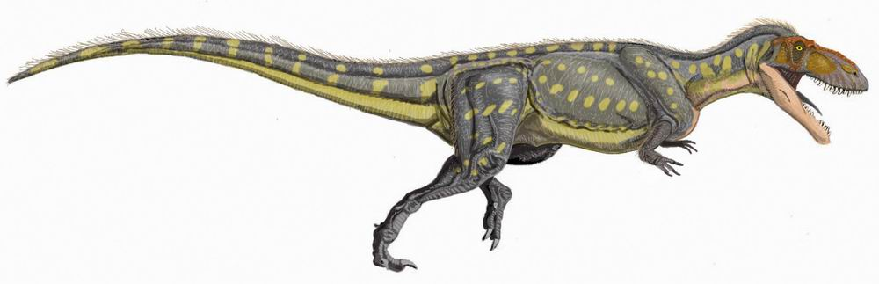

C. Mould fossil of the skin of the dinosaur Hadrosaurus.
Hadrosaurus was a plant eating dinosaur that lived around 84,000,000 years ago. It had a bulky body about 10 metres long and a stiff tail.
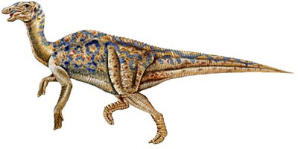

D. Cast fossil of a footprint made by the dinosaur Tyrannosaurus Rex.
Tyrannosaurus Rex was a huge meat eating dinosaur that lived around 85,000,000 years ago. It had a huge head with pointed teeth, tiny arms but feet up to 1 metre long!
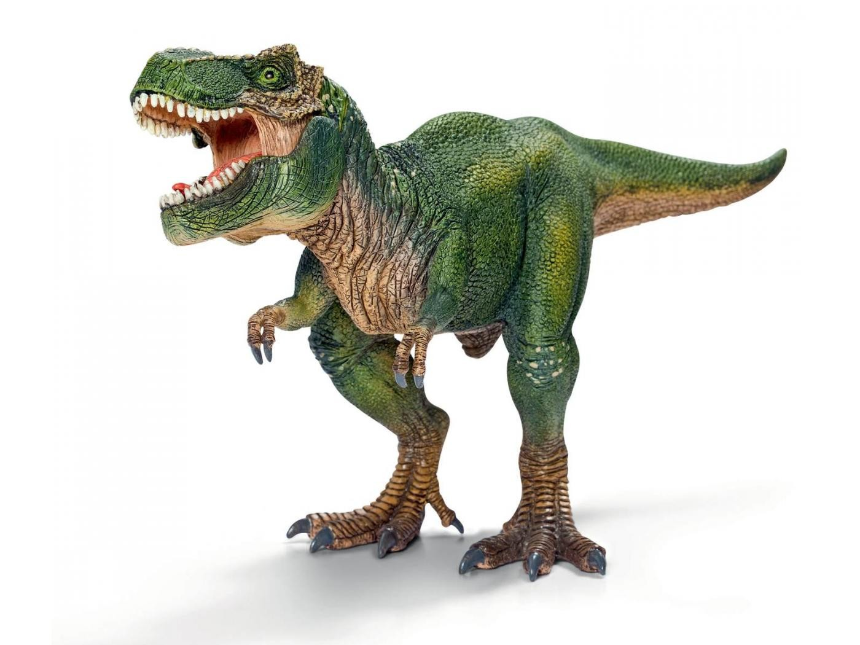

E. Cast fossil of dinosaur poo (coprolites).
By examining fossilised poo from millions of years ago, scientists can figure out if they were created by carnivores, herbivores or omnivores. They can sometimes even identify the type of animal or plant that the dinosaur ate before going for a ‘Number 2’.
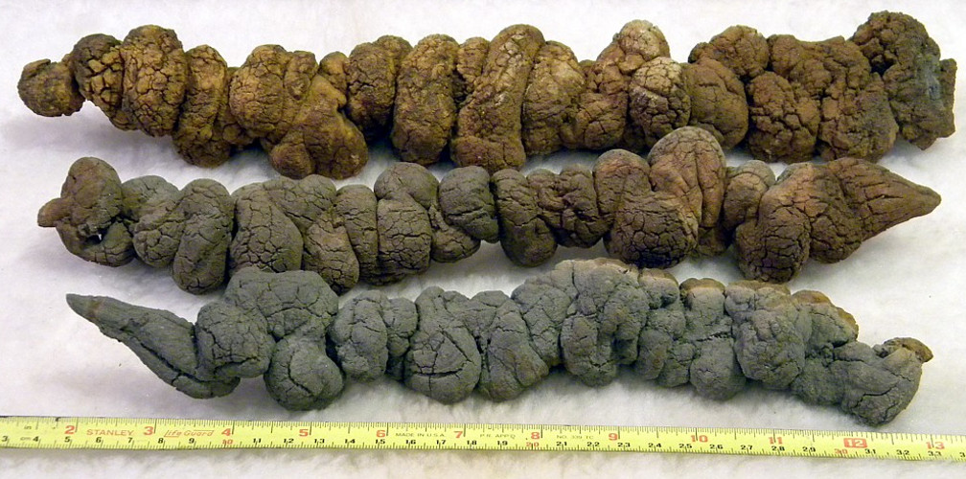

F. Insect trapped in hardened tree sap.
Fossils can form in unusual ways. Small bugs or insects can become trapped in sticky tree sap. Over many years, the sap becomes hard and forms a material called amber.
In some pieces of amber you can find the remains of organisms.
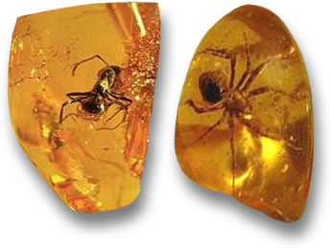

G. Mould fossil made by leaves of a fern plant.
Ferns are believed to be the very first type of plant to grow on land around 350,000,000 years ago. They would have been an important source of food for plant-eating dinosaurs such as the Diplodocus.
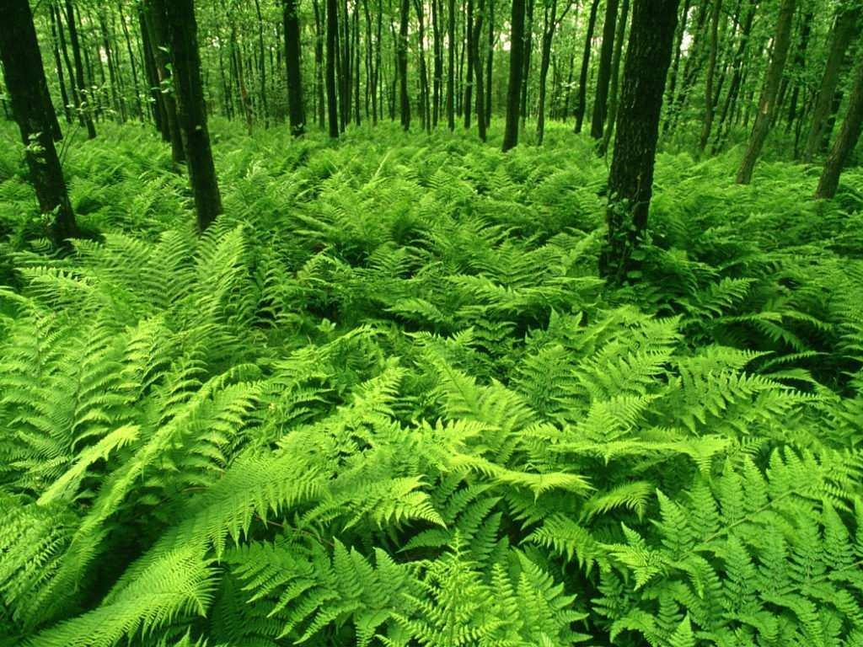

H. Cast fossil made by ammonites.

Ammonites are perhaps the most well known fossil. These creatures first appeared in the seas up to 415,000,000 years ago. They had a ribbed, spiral shaped outer shell and this was hard and strong enough to protect their soft body.



