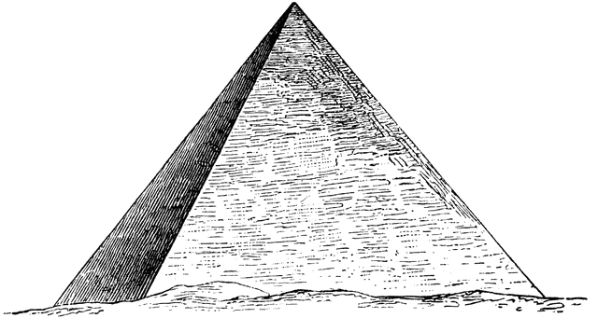
Number Pyramids
(Two adjacent bricks add to give the brick above them.)
RED – Completing pyramids by adding
1.  5  8  13 | 2.  15  21  37 | 3.  23  9  54
4.  35  27  11 | 5.  19  53  21 | 6.  17  60  42
AMBER – Completing pyramids by adding and subtracting
1.  32  15  7 | 2.  72  39  15
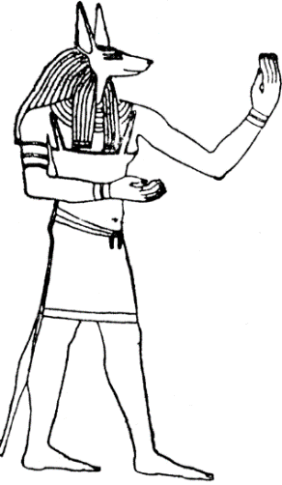
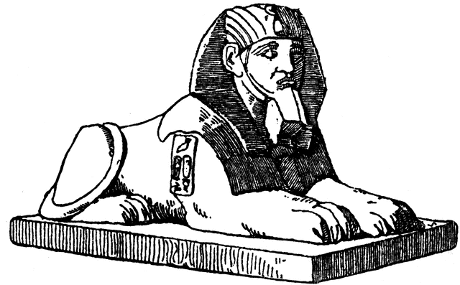
3.

62
41

26

12

GREEN – Problem solving with pyramids
1.  49  14  25 | 2.  58  8  10
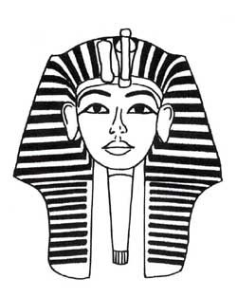
3.

117

25

22
17

4

Number Pyramids
(Two adjacent bricks add to give the brick above them.)
RED – Completing pyramids by adding
1.  34  13  21  5  8  13 | 2.  94  36  58  15  21  37 | 3.  95  32  63  23  9  54
4.  100  62  38  35  27  11 | 5.  146  72  74  19  53  21 | 6.  179  77  102  17  60  42
AMBER – Completing pyramids by adding and subtracting
1.  56  32  24  15  17  7 | 2.  72  33  39  15  18  21
3.
139

77

62
41
36

26
29

12
7

19

GREEN – Problem solving with pyramids
1.  49  19  30  14  5  25 | 2.  58  28  30  8  20  10
3.
117
60

57

25
35

22
17
8

18

4

