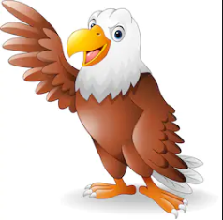
SMSC
Understand refugee from the past and present
One World

Grammar
Clause/phrase difference
Subordinate clause
Word families
Standard English

Science
Animals including humans
The digestive system
Types and functions of teeth
Tooth decay
Food chains

English
Letter from the lighthouse – Carol – Class debate pg 233-237)
Persuasive writing linked to whole class debate.
Drama- Evacuee day
Newspaper reports – The Blitz
Poetry – Wilfred Owen

Use colours and blending to create camouflage
Maths
Recap term
Shape (2D/3D)
Measure & Length
Money
Time
Computing
Hardware investigators
Geography
Movement of troops – Compass skills
Spelling
Recap key words and spelling patterns including common exception words.
Music
Call and repeat songs
Golden Eagles
Term 6
World War II

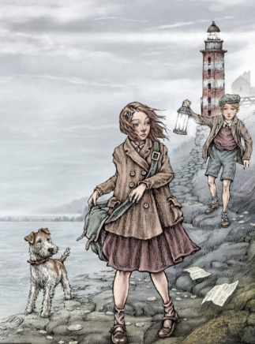
History
- Local effects
-Living in war time
- Holocaust
- The role of women

P.E
Sports day practice/ activities
R.E
Big Questions
Times Tables
Recap all times tables
Problem solving and word problems
DT
Design your own plane.
Plane mobile

